**Camp SMILE Handbook**

Table of Contents

**Introduction**

Camp SMILE 1

Core Values 4

Goals and Objectives 5

**Administrative Policies**

Policies 7

General Conduct 10

Personnel Policy 13

Counselor Evaluation Form 15

Discipline Policy 16

Anti-Bullying Policy 17

Job Descriptions 20

Golden Rules 21

**Agreements**

Volunteer Agreement 23

Counselor Agreement 24

Lifeguard Agreement 25

Unit Leader 26

Horse Volunteer 27

Director 28

**Safety, Emergencies, & First Aid**

Safety 30

Lost Camper Procedures 31

Weather Emergencies 32

Emergency Medical 33

Incident Reporting 34

Code Red 35

Universal Precautions 37

Child Abuse Policy 38

**Procedures**

Trashy Tribe 40

Cabin Duty 41

Counselor Check In/Out 42

Camper Check In/Out 43

Pavilion Dining 46

Camp Trolley 46

Curfew/Break 46

Lost Items 47

Inventory & Laundry 48

Horseback Policies 53

Waterfront Policies 54

**Conditions & Disabilities**

Intellectual Disability 56

Down Syndrome 57

Cerebral Palsy 57

Spina Bifida 59

Muscular Dystrophy 59

Diabetes 60

Epilepsy 61

Deafness & Hearing Loss 61

Blindness 62

Traumatic Brain Injury 63

Autism 64

ADHD 65

Speech Impairments 66

Multiple Disabilities 67

Dementia 67

**Communication**

Definition 69

ASL Alphabet 70

Sign Language:

Basic Signs 71

First Aid 73

Time and Place 74

Food and Drink 75

Camp Activities 76

Daily Living 77

People 78

Animals 79

Miscellaneous 80

Ten Commandments 81

**Behavior Management**

Behavior Management Policy 83

Preventing Problems 87

Meltdowns vs. Tantrums 88

**Positioning & Handling**

Equipment 90

Wheelchair Safety 91

Principles 92

Wheelchair Prep 94

Transfers 95

Sitting 98

**Games 99**

**Purpose**

A Letter to You 102

Discovery of Purpose 103

Special People SMILE 104

***Introduction***

You have been selected to work at United Cerebral Palsy’s **Camp SMILE** because of your positive attitude and personal skills. We commend you for your desire to serve others. You have already learned a very important principle – when you serve others to the best of your ability, you will be rewarded.

The rewards are not necessarily material things. When you help an individual and see the triumphant smile of accomplishment – you are rewarded. Likewise, the other experiences that you’ll receive will help you become an even stronger, well rounded person. You’ll learn more about yourself and others in this short period of time than you would ever imagine.

As you get to know and make friends with the other staff, you will soon realize that you are working with a great group of people. You will develop a common bond with other staff. Each of you is working to make **Camp SMILE** a very special place for the campers. You’ll find the warmth and love that you share with the campers and other staff will be returned to you many times over.

Hopefully, you will enjoy most of the camp activities. There will be times, however, when things aren’t going so well, when you have never been so tired in your life. Along with the enjoyable aspects, you’ll find your job to be physically and mentally demanding. Yes, you’ll pay your dues, but they’ll be small in comparison to the lifelong memories and personal growth you’ll take with you.

We’re glad you’re here and ready for the challenges that face you. We will do our best to provide you with the necessary training, support, and encouragement.

You have a world of opportunities while working at **Camp SMILE**. We wish you the best in your efforts to make the most of them. Read through this manual and familiarize yourself with all that is in it. As a staff member, you will be responsible for knowing the contents of this manual. If any material contained in the manual is unclear, address your questions with directors and unit leaders.





**PURPOSE**

**Camp SMILE** is a residential camp for children and adults with and without disabilities. **Camp SMILE** provides a wide range of recreational experiences for its campers, respite services for families, and an opportunity for teenage and adult volunteers to experience an awareness of the daily challenges of those who are disabled.

**Camp SMILE** provides a summer camping experience to those whose mental and physical abilities prevent them from attending other camps. Central to **Camp SMILE’s** programs is the provision of leaders who have obtained educational degrees in the fields of intellectual disability, multiple disabilities and early childhood development.

Also central to the program is medical support. These provisions insure that every individual—regardless of the degree of mental, physical, and/or medical problems, can participate in this life changing experience.

**HISTORICAL INFORMATION**

**Camp SMILE** was founded in June of 1972 by Reverend Glenn Vernon and his wife Sylvia. The first camping session was four days and three nights and served 27 campers. Currently, 300+ campers are served every summer.

**POPULATION SERVED**

**Camp SMILE** is open to all races and denominations and is designed to meet the needs of persons with mental and/or physical disabilities between ages five (5) and fifty (50).

**SPONSORSHIP**

**Camp SMILE** is sponsored by United Cerebral Palsy of Mobile, Inc.

**LOCATION**

All four weeks of **Camp SMILE** are held at Camp Grace, just off Eliza Jordan Road in West Mobile.

**STAFF**

The President/CEO is **Glenn Harger** (United Cerebral Palsy of Mobile, Inc.)

Camp is led by a team of devoted individuals, who make up the Leadership Team:

**Matrisza Alvarez**, Director, holds a B.S. Degree in Recreational Therapy. She has been involved with **Camp SMILE** in various positions for over 20 years.

**Molly Schemm**, Assistant Director, holds a B.A. Degree in Psychology, with an emphasis on Child Development, and a Minor in Applied Behavioral Sciences. She began working with **Camp SMILE** in 2018.

**Martha White** holds a Master’s Degree in Special Education with an emphasis in Intellectual Disabilities and is retired from the Mobile County Public School System. She began as a counselor and has been with **Camp SMILE** since 1978.

The **Camp SMILE** staff consists of up to eight Unit Leaders, each assigned to direct one (or more) of eight Tribes. The Unit Leaders assist and supervise counselors in all areas of camp life, especially related to camper care, safety and Pod area maintenance. All Unit Leaders have degrees in Special Education or related fields.

The **Camp SMILE** staff also includes Daily Volunteers, a Waterfront Director, Lifeguards, Medical Staff, Counselors, and many other volunteers.

The **Camp SMILE** Counselor is a vital and most important member of the staff. The counselor is responsible for the direct care of the camper at all times. She/he is required to follow a schedule of activities and insure that the camper participates to the best of his/her ability. The position of counselor is a voluntary and highly responsible one. Applicants should be sixteen (16) years of age or older. They should be mature and conscientious individuals who are able to make rational decisions, and have a sincere love of people.

**PROGRAMMING**

Program activities are designed to be adaptive to all degrees of mental and physical abilities. Adaptation in large part, however, is the responsibility of the counselor who deals one on one with his/her camper daily. This requires that counselors exercise their creative abilities, therefore making camp beneficial not only to the campers it serves, but to themselves as well.

***Camp SMILE Core Values***

Camp SMILE counselors often tell us that camp changed their lives. Camp provides a unique opportunity for you to grow and learn about yourself as a person, while you live in service to others during your time at camp. Camp SMILE strives to instill the following ten core values in our counselors. We honor counselors who exhibit these values with special awards given each week:

1. Integrity (*Eagle Award*): Doing what is right even when it is hard to do
2. Compassion (*Mama Award*): Having a compassionate nature and accepting spirit, allowing you to see your camper through a mother’s eyes
3. Respect (*Respect Award*): Willingness to treat others with sensitivity and finding value in the contributions of each
4. Passion (*Sunshine Award*): Passion and dedication to Camp SMILE and doing your job with pride
5. Selflessness (*Unsung Hero Award*): Selflessness towards others, setting an example of who we all strive to be; being a Camp SMILE hero
6. Communication (*Good Buddy Award*): Using communication to build relationships, and building friendships based on these relationships
7. Purpose (*Purpose Award*): Combining all of the core values, effecting positive change in the life of campers and others
8. Spirit (*Spirit Award*): Possessing the uninhibited spirit and weirdness necessary to make Camp SMILE a fun place to be
9. Unity (*Unity Award*): Using spirit and teamwork daily to promote camp unity and make Camp SMILE a better place for everyone
10. Grit (*Grit Award*): Ability to persevere when the going gets tough and recovering from a setback with a SMILE



Goals and Objectives

The goal of Camp SMILE is to empower children and adults with disabilities to live their lives without limits by providing an inclusive summer camp experience where there is no limit to the adventure. We offer a typical camp program with the medical support and trained staff needed to enable these children to participate as fully as possible.

Throughout the week, remember the following goals:

1. **To develop in each camper an enjoyment and appreciation of the natural surroundings they experience at camp.**

Staff will foster discussion that will result in a heightened awareness of our setting and the impact of our environment. This is accomplished in a variety of activities including horseback riding, arts and crafts, and swimming. The outcome is increased appreciation for the outdoors and value of spending time in nature.

1. **To give campers an opportunity for growth and development of self-confidence.**

Campers will gain self-confidence as they participate in all activities to the extent of their physical capacity and listen to the encouragement offered by counselors and staff. Camp SMILE operates on a “Challenge by Choice” principle and counselors are trained to foster independence by focusing on campers’ abilities and by encouraging campers to make their own choices. NOTE: For some campers, just being away from home and family is an opportunity for growth and development of self-esteem, especially considering that these children live with disabilities.

1. **To give campers opportunities to have new experiences and acquire new skills.**

Participation in the variety of activities provided by Camp SMILE will allow campers to achieve a basic familiarity with new sports, art, and various activities that enhance some elementary skills.

1. **To allow campers to improve their social skills by forming new friendships with campers and counselors.**

Camp will provide a supportive, inclusive environment where campers will feel free to reach out to others and form new, long-lasting friendships by sharing in camp experiences together. Holiday parties, fundraisers, and weekend respite camps help to maintain these friendships throughout the year, which leads to the outcome of an increased support system for campers and their families.

1. **To respect the rights and dignity of each camper.**

Camp provides a place of inclusion, respect, and dignity for everyone who is on campus, in any capacity. Campers are free to be themselves, and counselors are trained to be respectful and to preserve dignity in every situation. In turn, everyone at Camp SMILE feels safe, supported, and encouraged to be their best selves.

## *Administrative Policies*

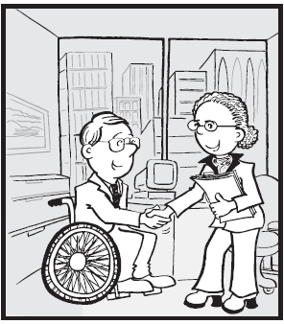

**Administrative Policies**

**CONFIDENTIALITY:** Camp SMILE volunteers are responsible for maintaining the confidentiality of all privileged information to which they are exposed while serving at camp, whether this information involves a staff member, volunteer, camper, or other person, or involves overall Camp SMILE business. Failure to maintain confidentiality may result in termination of the volunteer’s relationship with Camp SMILE or other corrective action.

**\*\*This means that while the medical information, personal histories, etc. learned about campers is essential to your success at camp, it may not be discussed outside of camp!\*\***

**Internet Policy:** For liability and trademark reasons, it is important that we protect the legal integrity of Camp SMILE’s name. It is even more important that we protect the privacy and safety of campers, who often share information about themselves online in connection with their experience at Camp SMILE. Counselors and staff should avoid electronic communication or posting that could be viewed by outside persons who have ill intent. We are also asking that no one create a web page of their own that could be mistaken in any way as an official website for Camp SMILE or that might otherwise create the appearance that Camp SMILE has endorsed the web page. We realize that such pages might appear harmless on their face, but we are advised by legal counsel that counselors and staff should remain diligent to protect the integrity of Camp SMILE’s name, as well as the safety and privacy of campers.

**\*\*\*THIS MEANS YOU MAY NOT POST A PICTURE OF YOUR CAMPER ON FACEBOOK, TWITTER, INSTAGRAM, SNAPCHAT, VSCO, ETC.\*\*\***

**STAFF AGREEMENT**: Each staff member will receive an agreement stating the terms of his/her stay at camp. By signing, you indicate that you understand the following:

* You will align yourself with the camp objectives, policies and guidelines.
* You are responsible for the campers AND to your supervisors.
* You will represent yourself and Camp SMILE in a professional manner and with appropriate attitude.
* The Camp Directors reserve the right of dismissal at any time your services become unsatisfactory.

**DISCIPLINARY COUNSELING AND ACTION**: At any time you break your agreement to follow camp rules, policies or procedures, display inappropriate attitudes or represent camp in an unprofessional manner, you will be subject to disciplinary counseling and action. This will be handled by one or more members of the Leadership Team.

***Disciplinary Counseling*** is defined as a conference with the Leadership team. The conference will deal with specific problem situations. The counselor will be given the opportunity to rectify the problem. If the pro]blem continues, disciplinary action may be in order. Depending on the situation privileges may be terminated, example: Return from break late – No break for the remainder of the week.

***Disciplinary Action*** will take place when:

* Counselor has required 2 disciplinary sessions with the Leadership Team, AND/OR
* Counselor is involved in one or more of the following….
  + Neglect or absence from assigned responsibilities
  + Insubordination
  + Gross misconduct
  + Fighting
  + Damage or unauthorized use of camp facilities or equipment
  + Violation of the law
  + Violation of camp rules, policies and procedures

***Action*** may necessitate sending the counselor home. A phone call will be made to parents. These calls will be made regardless of time of day or night. Those who drove vehicles to camp may be asked to leave immediately. Those requiring parental transportation may be required to have parents pick them up regardless of time of day or night.

**ILLNESS**: Counselors who are ill should notify their Unit Leader immediately. The Unit Leader will establish the degree of illness and make the decision to report to the Medical staff and/ or Director.

** This procedure is important to arrange for persons to fill in for the ill counselor and to guard against communicable illness spreading through the camp.

**TRAINING**: Participation in Pre-Camp and weekly Mini Pre-Camps is required unless other arrangements have been made with the Director.

**GRIEVANCE PROCEDURES**: A staff member who has a grievance should first seek to resolve his/her difficulties by having a conference with his/her Unit Leader. Failing to reach a solution to stated problem, a conference should be requested with the Director. (Follow the Chain of Command)

**STAFF STANDARDS**: THE PROFESSIONAL: As Camp SMILE team members, you are expected to work as a professional. Your positive attitude toward campers and fellow team members will go a long way in gaining respect for your ideas and feelings.

**PROFESSIONAL BOUNDARIES:** It is important to maintain a professional boundary between yourself, your camper, and your camper’s family. Do not discuss personal matters with your camper (or their family). Consult the Director or Assistant Director with any questions or concerns about maintaining these boundaries.

Sometimes, a camper’s family may ask that you babysit for your camper in the future. Counselors are responsible for making decisions about these arrangements on their own. Camp SMILE is not responsible for any relationships formed between staff and families outside of camp, professional or otherwise.

**TIPS:** Per UCP policy, do not accept gifts or other items with a fair value in excess of $150.00 without prior approval from the Director. Such gifts should be received on an occasional basis only.

It is important that you keep your supervisor(s) informed on what is happening in the camp. If you are aware of something that could hurt the campers or program, report it. If you do not report it, you negate the good efforts being put forth.

We should all work to achieve camp objectives and abide by the standards set for the camp. Standards of this camp are HIGH. Much strength (in your personal attitudes and conduct) is expected of you. Your relationships with campers and fellow staff members hinge on you keeping your “Best Foot Forward”.



***General Conduct***

j0238181**ALCOHOL & DRUGS**: The possession, sale or use of alcoholic beverages or drugs is PROHIBITED. Violation will result in IMMEDIATE DISMISSAL from the camp grounds. Law Enforcement officials will be notified. NOTE: All prescription drugs must be checked in and out with the Nurse and kept at the Med Shed.

j0232446

**ARGUMENTS** and heated discussions will not be in front of the campers. Problem situations should be taken to the Unit Leader, who will then decide if the problem requires further assistance.

**PRACTICAL JOKES**: There are **NO** Practical Jokes!!!!!!!!!!!!!!!!!!!!

* Practical Jokes and Bullying are too closely related and have resulted in the change of this policy!!
* **NO practical jokes whatsoever!!!!!!!!!!!**

**MATERIALS & EQUIPMENT**: You will have some responsibility for materials, supplies and equipment purchased, borrowed or donated for use in the camp program. Your diligent care and use of such items is expected, as well as your honesty in seeing that all materials are used for their intended purposes. No writing on any structures. Damage or loss of camp property due to negligence will result in disciplinary action and possible monetary reimbursement.



**EXPLOSIVES**: Use of fireworks, explosives or lighting of any fire is STRICTLY PROHIBITED and will result in disciplinary action.

**FRATERNIZATION**: Fraternization between staff that distracts or interferes with duties/responsibilities is PROHIBITED. Male personnel will not enter female cabins or vice versa except in emergencies when medical duties dictate, or if help is needed to lift a heavy camper. Disciplinary action will be taken if this policy is broken. Public Display of Affection (PDA) is limited to holding hands and should not be done around campers. Save all other PDA for dating on your own personal time. ABSOLUTELY NO SEXUAL ACTIVITY is permitted. Result is IMMEDIATE dismissal. Parents will be informed by YOU before leaving.

**SENSITIVE ISSUES**: Socially sensitive issues may be raised by campers during informal camp discussions. Examples of socially sensitive issues include drug use, alcohol use, tattoos and body piercings, sexuality, dating, religion, cults, divorce, smoking, ghost or horror stories, inquiries regarding the personal lives of staff, death, self-image, and personal information about other campers. These issues may be raised by campers in conversations regarding their own feelings, asking other campers what they believe, and/or asking staff about their beliefs. Maintain professional boundaries when discussing sensitive issues with campers—do not reveal any personal information about yourself or disclose your personal beliefs. Treat the inquiring camper with respect and dignity while declining to reveal personal information about yourself. If you are unable to effectively manage the situation, consult with your Unit Leader. At the discretion of the Unit Leader or Camp Director, parents may be contacted.

**GUESTS**: Are only permitted on Saturdays for Talent Show!

**INJURIES AND/OR ILLNESS**: Ask a medic/nurse to look at **ALL** injuries and illnesses. Do not try to play doctor on your own, even for little scrapes and bumps.

**LEAVING CAMP**: Everyone, regardless of age, must notify one of the Directors before leaving camp. Leaving camp during the week is only allowed in emergency situations.

**OFF LIMIT AREAS INCLUDE**:

* Inside the Med Shed
* Kitchen
* Canteen Storage Room
* Lake at Night
* Any room/building with lights off after dark
* Lake during break (unless lifeguard is on duty)
* Woods at night
* Cabins of opposite sex
* Any staff room
* Laundry room
* Parking lot (unless coming or going)

**PERSONAL GROOMING/CLOTHING**:

* + - Staff is requested to be as well-groomed as possible.
    - Individuals should be clean, hair combed/brushed, etc.
    - All staff must bathe daily.
    - Clothing should be changed on a regular basis.
    - Shirts should cover bellies completely.
    - Underwear must be worn at all times, except when swimming.
    - Footwear must be worn at all times outside of the cabin.
    - Males should wear shirts when not sleeping /swimming.
    - Shirts & shorts must be worn over swimsuits when not at lake.

**PERSONAL POSSESSIONS**:

Do NOT bring large amounts of cash or valuable items.

Camp SMILE is NOT responsible for loss or damage of personal property of staff.

**Guns & Knives** are **STRICTLY PROHIBITED** on camp grounds. Law enforcement

officials will be notified.

**QUIET SIGNAL**: Our signal for quiet is one hand up over head.

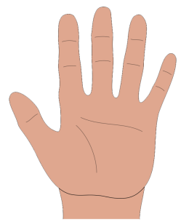**\*\*\*HAND UP, MOUTH CLOSED!!!!!!**

**PUNCTUALITY**: Every staff member is expected to be up and at the flag pole at the designated time. Staff members will be on time for all scheduled program events, meals, meetings and any other responsibilities.

**SNACKS**: No carbonated drinks, gum, candy or other snacks will be

consumed in front of campers if not supplied through the kitchen.

A snack will be provided during the nighttime break.

Absolutely no food in the cabins!! We do not want to sleep with the critters!

 **TELEPHONE USAGE**:

1. Cell Phones are STRONGLY DISCOURAGED at camp. Please leave them at home or in your car!
2. If there is an emergency and you need to be reached, your parents may contact Matrisza at 251-656-2656 or Molly at 785-215-0111.
3. If a cell phone is found at any time, it WILL be taken up and returned at the end of the week.
4. Individuals receiving calls will be given a message. You must then receive permission to return the phone call.

**TOBACCO PRODUCTS**:

Camp Smile is a tobacco free facility. There will be **NO** smoking or chewing tobacco on Camp Grace property.

**TATTOO & PIERCING POLICY: Due to the consideration that we extend to our campers, we ask you to refrain from getting tattoos, piercings, or any other physical alterations that will prohibit you from engaging in regular camp activities.**

**REST**:

* Rest is important and all staff members are expected to be prepared for the next day.
* Getting enough rest is your responsibility and failure to do so is not an excuse for neglecting responsibilities.
* Lack of sleep due to camper problems or emergencies will be taken into consideration.
* **ALWAYS WAKE YOUR UNIT LEADER FOR CAMPER PROBLEMS DURING THE NIGHT. UNIT LEADER WILL DETERMINE IF MEDICAL STAFF/MATRISZA NEEDS TO BE INVOLVED!!!!**

**PET POLICY:** No pets or non-service animals are allowed on site without prior permission from the Director. The health and safety of our horses is monitored and maintained by the professional discretion of our Equine Director.

***Personnel Policy***

1. Camp provides equal opportunities to employees and applicants with regards to race, color, religion, sex, national origin, age, disability, and/or veteran status in accordance with applicable state and federal laws and UCP hiring policy.
2. Potential applicants are given a counselor agreement to review and sign that outlines job expectations, and camp procedures are discussed in the interview,
3. A background check is required for all volunteer and paid applicants aged 18 and over.
4. At least two references are required for all potential new volunteers. References are verified through phone and email correspondence.
5. All camp counselors are volunteers. Benefits are not provided. The only paid staff members are:
   * Director and Assistant Director
   * Kitchen Staff
   * Lifeguards
   * Horseback instructors
   * Unit Leaders
   * Housekeeping/Trash
   * Nurses
   * Paramedics
   * Night Security
6. Work hours are determined by contract agreement for each position based on availability discussed in interview. See agreements and job descriptions for more information.
7. Time off is addressed as follows: Each counselor will be given night time breaks with the exception of 1 duty night. Break begins when the Unit Leader dismisses the Counselor and ends at 11:30 p.m. This means showers, bathroom, and tooth brushing must be done before 11:30 p.m. Night time break area is limited to the Recreation hall, and other areas provided by the leadership team on nights of special counselor events. **NO** visiting people on duty in the Pods during break.
8. Grievance Procedures: A staff member who has a grievance should first seek to resolve his/her difficulties by having a conference with his/her Unit Leader. Failing to reach a solution to stated problem, a conference should be requested with the Director. (Follow the Chain of Command)
9. Potential paid Unit Leaders and Nurses are vetted by our current Unit Leaders and Head Nurse, respectively. In addition to the basic volunteer application, paid staff must provide a signed **contract employee info sheet**, a HIPPA form, a copy of their driver’s license and their social security card, and a copy of their professional certification.
10. All new paid and volunteer staff is interviewed by the director and assistant director. Specific information will be given to each applicant about job responsibilities and the nature and diversity of camper population.
11. **Performance evaluations** are completed for each counselor at the end of each week by the Unit Leaders. The evaluations are then submitted to the Director. If evaluations are unsatisfactory, counselors are given a copy of their evaluation and a meeting is scheduled with the Unit Leader and Director or Assistant Director. Counselors are also given an opportunity to evaluate their Unit Leaders at the end of each week. Appropriate action is taken if necessary.
12. Smoking is prohibited.
13. No alcoholic beverages or illegal drugs are allowed on camp property.
14. All medications will be dispensed by the Med Shed, including the staffs’ own prescription drugs. No exceptions to this will be permitted.
15. No sexual conduct or contact of any kind is allowed at camp between staff or between staff and campers.
16. Camp SMILE prohibits any sexual harassment or sexual discrimination. Should either occur, the following procedure is followed: **See UCP policy and child abuse reporting form.**
17. The allegation is immediately reported to the Director, who in turn reports it to the necessary supervisory staff members and the UCP Board of Directors, which includes the Camp’s attorney.
18. The allegation, the complainant, and the alleged offender are all kept confidential and only revealed to the necessary supervisory staff members.
19. The complaint is reviewed by the Director and members of the Board of Directors as soon as possible, but at least within 24 hours from the time the allegation is made and reported to the Director.
20. Once reviewed by the Director and the Board of Directors, appropriate action is taken. Such action can range from disciplinary action to termination of duties.
21. All individuals are assured that no retaliatory action will be taken against any staff member who makes a good faith report of such harassment or discrimination.
22. No physical punishment of campers is allowed. Any physical punishment of campers will be met with immediate dismissal.
23. All counselors and volunteers shall be a minimum of 16 years of age.



**Counselor Evaluation Form**

1. Counselor followed written camp policies to ensure safety, order and organization. (Keeping up with personal & camper belongings)

U N S

1. Counselor appropriately collaborated with all other fellow counselors.

U N S

1. Counselor remained at camp for the entire session.

U N S

1. Counselor stayed with camper(s) at all times (no unauthorized leaving or camper swapping).

U N S

1. Counselor helped to maintain order and safety among campers (making good decisions).

U N S

1. Counselor adequately took care of camper’s daily needs (feeding, dressing, changing, bathing, hydrating, applying bug & sun products and remembering med line).

U N S

1. Counselor demonstrated acceptance of personal differences amongst campers, respect for privacy, and modesty in group living situations.

U N S

1. Counselor put camper’s needs before his/her own.

U N S

1. Counselor helped to maintain cleanliness of camp. (cabin, pavilion, rec hall, art room, restrooms & grounds)

U N S

1. Counselor had a positive attitude, listened to and showed respect for campers, fellow counselors, and leadership staff, and participated in all camp activities (Camp Spirit).

U N S

1. Counselor observed camper behavior, evaluated its appropriateness, chose appropriate behavior management techniques (learned at counselor training) and implemented them effectively.

U N S

12. Counselor made sure their camper(s) were on time for scheduled activities and encouraged  
 camper participation.  
 U N S

* Notes: _____________________________________________________________________

_____________________________________________________________________

_____________________________________________________________________

_____________________________________________________________________

_____________________________________________________________________

Counselor Signature: _____________________________________________________________________

Unit Leader Signature: _____________________________________________________________________

Director Signature: _____________________________________________________________________

***Discipline Policy***

1. At no time, and for no reason, is there to be physical punishment of campers.
2. If discipline cannot be achieved through the approach of friendship and reason, the problem is to be brought to the attention of the Camp Director.
3. Punishments, such as isolating the problem camper from others, verbally threatening, or acts that involve camper’s personal belongings are not permissible by the counselor.

1. Realize that this matter regarding physical punishment is for your own protection. It may be misconstrued as physical abuse. Any physical punishment of campers will be met with immediate dismissal.

1. If you have a camper who is physically abusing or tormenting others, inform the Unit Leader of the cabin, who will resolve the problem if possible. He/she will consult the Camp Director who will make any final decision concerning the camper being sent home. Camp is for all, and this type of behavior is unfair to the other campers.

***Anti-Bullying Policy***

Bullying is when one or more people exclude, tease, taunt, gossip, hit, kick, or put down another person with the intent to hurt another. Bullying happens when a person or group of people want to have power over another and use their power to get their way, at the expense of someone else. Bullying can also happen through cyberspace: through the use of e-mails, text messaging, instant messaging, and other less direct methods. This type of bullying can also lead to persons being hurt during or between the camp seasons and be especially hurtful when persons are targeted with meanness and exclusion.

**At Camp SMILE, bullying is inexcusable, and we have a firm policy against all types of bullying.** Our Camp philosophy is based on our mission statement which ensures that every camper has the opportunity to feel empowered to live their lives without limits by having an inclusive summer camp experience where there is no limit to the adventure. We work together as a team to ensure that campers gain self-confidence, make new friends, and go home with great memories.

**Reporting Instances of Bullying:**

All suspicions or witnessing of bullying are to be taken seriously and to be reported to a Unit Leader immediately. The Unit Leader will then work with the counselor to fill out an incident report and discuss actions to take with the Camp Director. “Actions to take” may include a discussion with those involved, a phone call home, disciplinary action, or an abuse investigation.

Unfortunately, persons who are bullied may not have the same potential to get the most out of their camp experience. Our leadership team addresses all incidents of bullying seriously and trains staff to promote communication with their staff and their campers so both staff and campers will be comfortable alerting us to any problems during their camp experience and between camp seasons. Every person has the right to expect to have the best possible experience at camp, and by working together as a team to identify and manage bullying, we can help ensure that all campers and staff have a great summer at Camp SMILE!

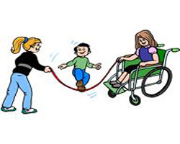

***The Bully Coach Guide to Spotting and Stopping Bullying at Your Camp: QUICK TIPS for Counselors***

BULLYING is any intentional hurtful act, committed by one or more persons against another. Bullying occurs when there is an imbalance of power between a bully and a victim. The main types of bullying include:

* **Physical** — punching, hitting, shoving, stealing personal things, or getting into someone’s personal space when asked not to.
* **Verbal** — name calling, hurtful teasing, taunting, unwanted nicknames, gossiping
* **Relational** — exclusion, humiliation, blackmailing, manipulating friendships

Who are the **“bullies”?** Bullies are often smart, popular, well-liked, and have good social skills. They may look like leaders and be liked by counselors and other campers, but bullies lack empathy. The “victims” on the other hand show some vulnerability that makes them easy targets. As a counselor, you need to be aware of those kids that may be left out or have a difficult time fitting in or making friends.

As a **counselor**, your role is to be a hero! You need to discuss camper rules and role model the behavior that you ask them to follow. Let campers know that bullying is unacceptable and won’t be tolerated. Do not play favorites with some campers since that would show them that it is okay to “exclude” others. Bullying usually occurs in places when counselors are not around, so it is important to make bullying a regular topic of discussion with your campers on a weekly basis at a minimum, so they know you take it seriously.

When a counselor observes bullying of any kind, they must intervene by stepping in and separating the children involved. Support the victim, and report any bullying behavior to your leadership team immediately. Teach your campers to be a real “caring” community and let you know when they see someone left out, teased, or upset by someone else. Teach campers the difference between **reporting**: getting kids out of danger and into safety and **tattling**: telling on others with the intent to get someone in trouble. When a camper reports that he or she is being picked on, support him or her and keep an eye on the situation.

When you **role model** to your campers that you want them to be heroes themselves and step in to help another camper or find a counselor when there is a bullying problem, you have done a great job! Campers follow your actions much more than they follow your words. Make camp a place where everyone feels valued by how you bring everyone together.

*This guide is a summary of some important information found in the “Bully Coach Counselor Guide” (www.respectu.com).*

***Staff Policies***



Job Descriptions

**The Camp Directors**: Responsible for the overall operation of Camp SMILE. They are responsible for supervision and training of all staff. They are also responsible for camper and counselor safety.

**The Unit Leaders**: In charge of assigned cabins. They assist and supervise counselors in all areas of camp life, especially related to camper care, safety and cabin maintenance. They are responsible for assisting the directors in training counselors; responsible for insuring counselor attendance at all activities and coordination of cabin downtime; and responsible for orderly gathering and washing of laundry. Report to Camp Directors.

**The Equine Director:** Responsible for overseeing all aspects of horseback riding program. Ensures that all horse activities are run smoothly and safely and are prepared daily prior to camper arrival. Responsible for maintenance of horses and horse facilities. Reports to Camp Directors.

**The Waterfront Coordinator**: Ensures that all water-related activities are run smoothly and safely and are prepared daily prior to camper arrival. Responsible for training lifeguards and enforcing waterfront policies. Reports to Camp Directors.

**The Lifeguards**: Ensure that all water-related activities are run smoothly and safely and are prepared daily prior to camper arrival. Report to Waterfront Coordinator and Camp Directors.

**The Medical Staff**: Responsible for checking in/out both camper and counselor medication. Disbursing and documenting medication. Handling of all medical emergencies as well as all minor medical problems and documentation thereof. Responsible for setting up and maintenance of Medic Station. Reports to Camp Directors.

**The Counselors**: Responsible for assigned camper/s at all times. Responsible for supervision, safety, assistance (partial or total) of campers during bathing, eating, dressing and participation in activities. Ensure campers report to nurse at scheduled medicine times. Responsible for all campers’ belongings. Immediately responsible to Unit Leader.

**Volunteers:** Responsible for supervising campers and ensuring safety at their assigned activity area(s) and carrying out duties as needed. Report to activity leaders and Directors.

***Camp SMILE Golden Rules***

* IF YOU OPEN IT, CLOSE IT
* IF YOU TURN IT ON, TURN IT OFF
* IF YOU UNLOCK IT, LOCK IT
* IF YOU BREAK IT, REPORT IT
* IF YOU BORROW IT, RETURN IT
* IF YOU USE IT, TAKE CARE OF IT
* IF YOU MAKE A MESS, CLEAN IT UP
* IF YOU MOVE IT, PUT IT BACK
* IF IT BELONGS TO SOMEONE ELSE, GET PERMISSION
* IF YOU DO NOT KNOW HOW TO OPERATE IT, LEAVE IT ALONE
* IF IT DOESN’T CONCERN YOU, DON’T MESS WITH IT

***Remember: Camp is for the campers!***

***Agreements***





Volunteer Agreement

1. I understand that even though I am a volunteer, I should consider my work at Camp SMILE as my job. I realize that I am a member of a team dedicated to providing an enriching experience for its campers.
2. Adult volunteers will maintain order, safety, and discipline among counselors and campers. The best means to achieve this is, of course, by example. At no time will a staff member use physical punishment or verbally abusive comments to discipline a camper or counselor.
3. No staff member will ever be alone with a camper. This is for your protection as well as the protection of the campers. For legal reasons, all allegations of physical or sexual abuse are treated seriously and referred to the State of Alabama for full investigation. Camp SMILE has a zero tolerance policy regarding all allegations of physical or sexual abuse of a camper.
4. Volunteers will adhere to the **no smoking/no tobacco** policy.
5. I understand that Camp SMILE has a strict **no tolerance** policy as it pertains to drugs and alcohol and as a part of this policy I will be subject to random drug searches conducted by Mobile County Canine Drug Force.
6. I will carry out the duties assigned to me by the camp directors.
7. I will be punctual and work the length of my agreed upon shifts.

I have read and agree to uphold all responsibilities listed above. I also agree to serve as a positive role model.

_______________________________ _________________________

Signature Date

_______________________________ _________________________

Parent Signature (if under 18) Date



Counselor Agreement

1. I understand that even though I am a volunteer, I should consider my work at Camp SMILE as my job. I realize that I am a member of a team dedicated to providing an enriching experience for its campers.
2. I understand that if I break any Camp SMILE rule, policy or procedure, or fail to display appropriate attitudes, that I am subject to disciplinary counseling and action as seen fit by camp directors.
3. All counselors will remain at camp the entire session: It is extremely distracting to campers to develop a rapport with a counselor and then have the counselor gone for several hours or more.
4. Counselors will be responsible for the whereabouts of assigned campers at all times.
5. No counselor will ever be alone with a camper: This is for your protection as well as the protection of the campers. For legal reasons, all allegations of physical or sexual abuse are treated seriously and referred to the State of Alabama for full investigation. Camp SMILE has a zero tolerance policy regarding all allegations of physical or sexual abuse of a camper.
6. Counselors will maintain order, safety and discipline among campers. The best means to achieve this is, of course, by example. At no time will a staff member use physical punishment or verbally abusive comments to discipline a camper.
7. Counselors will supervise and/or assist campers with daily living skills such as: personal hygiene, dressing, eating, etc.
8. Counselors will report any health concerns of campers or staff to the Medical Staff.
9. Counselors are key in contributing to the “spirit” of Camp SMILE. This involves maintaining a positive, cheerful attitude, being a good listener for campers and fellow staff, encouraging participation in all activities; for example, if campers are swimming, then you should be swimming as well.
10. Counselors will adhere to the NO SMOKING policy.
11. I understand that I can be asked to leave camp and resign my position with or without cause at any time at the behest of Camp staff and/or administration.
12. Counselors will be responsible for maintaining cleanliness of cabins and other assigned areas.
13. I agree to the above conditions and will do my best to contribute to each and every camper’s experience.

_____________________________________ _____________________

Signature Date

____________________________________ ______________________

Parent Signature (if under 18) Date



***Lifeguard Agreement***

1. I understand that even though I am a volunteer, I should consider my work at Camp SMILE as my job. I realize that I am a member of a team dedicated to providing an enriching experience for its campers.
2. I understand that if I break any Camp SMILE rule, policy or procedure, or fail to display appropriate attitudes, that I am subject to disciplinary counseling and action as seen fit by camp directors.
3. I understand that I can be asked to leave camp and resign my position with or without cause at any time at the behest of Camp staff and or Directors.
4. I agree to work a pre-determined number of hours according to a schedule acceptable to my supervisor.
5. I agree to notify my supervisor as soon as possible when I am sick or unable to work.
6. Lifeguards will adhere to the NO SMOKING/NO TOBACCO policy.
7. I understand that Camp SMILE has a strict NO TOLERANCE policy as it pertains to drugs and alcohol and as a part of this policy my child will be subject to random drug searches conducted by Mobile County Canine Drug Force.
8. Lifeguards will maintain order, safety and discipline among campers. The best means to achieve this is, of course, by example. At no time will a staff member use physical punishment or verbally abusive comments to discipline a camper.
9. I agree to maintain a positive team relationship with fellow lifeguards.
10. I agree to carry out basic lifeguarding duties related to a lake setting:
11. Routine buddy checks
12. Effective scanning
13. Zone coverage
14. Checking swim site daily
15. Checking working order of boats, etc. daily
16. Following emergency procedures for severe weather and/or accidents
17. I also agree to the following duties specific to Camp SMILE:
18. Take out & put away life guard equipment daily.
19. Take life jackets, floats & water toys to lake. Be sure to hang/stack neatly at end of each day.
20. Set up, maintain & put away equipment daily.
21. Supervise and assist in loading & unloading boats.
22. Supervise and assist with fishing.
23. Assist in lifting non-ambulatory campers in/out of lake.
24. On each Saturday, bring all items to designated storage. On final Saturday, pack and inventory these items – give list to Matrisza.
25. Offer help at meal times and night time activities when possible.

I understand that I answer to the Waterfront Director and the Directors of Camp SMILE.

I have read and agree to uphold all responsibilities listed above. I also agree to serve as a positive role model, to carry out the duties and responsibilities of basic life guarding.

____________________________________ ______________________

Signature Date

____________________________________ ______________________

Parent Signature (if under 18) Date



Unit Leader Agreement

Monday:

* Be at camp on Mondays one hour before the counselors.
* In charge of bed assignments on bed sheets.
* Organizing the dorm for the week and talking to cabin counselors about your expectations.
* Assigning duties and jobs.
* Going over the laundry procedures weekly and ensuring that counselors know the process and where to get forms.
* Securing necessary items for cabins including trash bags, masking tape, sharpies, gloves, wipes, cleaning supplies, inventory/laundry sheets. Must request from Matrisza or Lilia items needed by campers by Tuesday at 2:00.

In The Dorm:

* Overseeing inventory on Tuesday mornings, checking all inventory forms, and making sure campers clothes are labeled.
* Assisting counselors with care of campers.
* Ensuring that campers are bathed and groomed daily.
* Overseeing and assisting with cleaning.
* Planning a variety of fun, appropriate activities for campers during cleaning time.
* Knowing where your counselors are at all times, making sure that everyone is where they should be, when they should be, enforcing curfew, and bed checks.
* Ensuring that your counselors are at activities on time.
* Keeping dorm tidy & organized after swimming.
* Ensuring that laundry gets to assigned laundry person and then getting cleaned laundry back to correct campers.
* Making sure all campers are clean, in pajamas and settled before dismissing counselors for break.
* Ensuring that counselors on duty are taken a snack.
* Thoroughly checking inventories at the end of the week and seeing that they match what is in the bag.
* Ensuring that camper’s luggage and belongings are all labeled prior to leaving cabins on Saturday morning.

Additional:

* Traveling with dorm when at all possible.
* Dealing with behavior issues in dorm and bringing these to the directors when warranted.
* Leading & setting up for activities when necessary, especially night time activities.
* Assisting any & all counselors during meals with feeding or behavior problems before you sit to eat. Reporting any & all broken rules to the directors.
* Supervising clean-up of camp grounds after campers leave, bringing any left items to the pavilion.

I understand that a Unit Leader leads by example. I will not ask counselors to do anything that I won’t do.

I have read and agree to the above duties and agree to carry them out to the best of my ability.

_____________________________________ _____________________

Signature Date



***Horse Volunteer Agreement***

1. I understand that even though I am a volunteer, I should consider my work at Camp SMILE as my job. I realize that I am a member of a team dedicated to providing an enriching experience for its campers.
2. I understand that the May 31st horse volunteer training at Camp Grace is **mandatory.**
3. Volunteers not spending the night must arrive promptly at 8am at the horse area and expect to stay until 6pm.
4. Volunteers will notify the Horse Instructors, Krystin Yates or Jason Barrett, as soon as possible when sick or unable to work.
5. Horse volunteers will maintain order, safety and discipline among counselors and campers. The best means to achieve this is, of course, by example. At no time will a staff member use physical punishment or verbally abusive comments to discipline a camper or counselor.
6. All volunteers must strive to maintain an upbeat and encouraging disposition during camp time.
7. Any horse volunteer that would like to be a trail ride guide must pass a riding test.
8. Volunteers need to be alert of their surroundings at all times and show their ability to take quick and appropriate action when working with campers and horses.
9. Volunteers must be able to lift up to 50 pounds.
10. All volunteers must wear closed toe shoes when around horses. Long pants are also recommended.
11. It is advisable for volunteers to provide their own snacks, drinks and sunscreen.
12. Volunteers are responsible for maintaining cleanliness of the horse area, as well as, their cabins.
13. No volunteer will ever be alone with a camper: This is for your protection as well as the protection of the campers. For legal reasons, all allegations of physical or sexual abuse are treated seriously and referred to the State of Alabama for full investigation. Camp SMILE has a zero tolerance policy regarding all allegations of physical or sexual abuse of a camper.
14. Volunteers will adhere to the NO SMOKING/NO TOBACCO policy.
15. I understand that Camp SMILE has a strict NO TOLERANCE policy as it pertains to drugs and alcohol and as a part of this policy I will be subject to random drug searches conducted by Mobile County Canine Drug Force.
16. I understand that if I break any Camp SMILE rule, policy or procedure, or fail to display appropriate attitudes, that I am subject to disciplinary action and/or possible removal from camp.
17. I understand that I can be asked to leave camp and resign my position with or without cause at any time at the behest of Camp staff and or Directors.

I have read and agree to uphold all responsibilities listed above. I also agree to serve as a positive role model and to do my best to contribute to each and every camper’s experience.

________________________________ ______________________________

Signature Date

________________________________ ______________________________

Parent Signature (if under 18) Date



Camp Director Agreement

WE AGREE TO:

1. Provide you with a clearly defined job description and the necessary training to enable you to do your job in an appropriate and adequate manner.
2. Treat you in a professional and respectful manner deserved by all human beings.
3. Deal with you fairly and consistently in all situations.
4. Be available to you when needed.
5. We understand that a director leads by example. We will not ask any counselor to do anything that we would not do ourselves.

______________________________ _____________________________

Matrisza Alvarez, Director Molly Schemm, Assistant Director

***Safety, Emergency, and First-Aid Procedures***

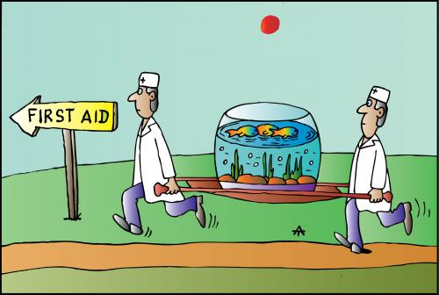

***Safety: The Number One Concern of Every Staff Member***

1. **CAMPER ASSIGNMENT**. The camp directors will assign you to your camper(s) at the Pre-Camp training. The counselor is responsible for the assigned camper’s safety AT ALL TIMES. Always know where your camper is AT ALL TIMES. The camp leadership team WILL DO frequent head counts.
2. No camper is allowed to go anywhere unattended. In addition no camper/counselor pair may travel or be alone. **The camper:staff ratio shall never exceed 2:1.**
3. Safety and potential hazards will be discussed at pre-camp training and at each weekly session.
4. It is the responsibility of each staff member to report any unsafe conditions or activities to the leadership team.
5. **DO NOT TAKE** any unnecessary risks that could endanger you, other staff, campers or camp property.
6. **GET TO KNOW YOUR CAMPER**. Learn the child’s allergies, sleep patterns, habits, etc. Review the information provided by parents, guardians, and the camper application.
7. Plastic forks & spoons are not allowed for campers that must be fed because of oral motor problems associated with various disabilities.
8. **ALWAYS CONSULT THE CAMPER’S APPLICATION** for food allergies. **DO NOT ALLOW** the camper to eat any foods they may be allergic to.
9. **FEEDING**. Take time for feeding. Cut food into small pieces to prevent choking.
10. Make sure proper covers are on electrical plugs that are in camper’s reach.
11. **NO** camper should sleep in a **top bunk**, unless otherwise directed.
12. Do not allow running or horseplay in the dorms.
13. Counselors should test the water temperature at shower, sink or tubs prior to camper use.
14. **MEDICATIONS**. Make sure all medications are kept at the med shed. Suntan lotion, shaving lotions, etc. must be stored in a high area to prevent campers from consuming.
15. The campsite has uneven terrain in places and a very tempting lake. If necessary, **hold the camper’s hand** when walking to activities.
16. With a camper who is unsteady, stand by them for support.
17. Keep your camper away from fire ants, wasps, or small animals.
18. **SUNSCREEN**. Apply sunscreen frequently to camper. Keep campers in the shade as much as possible. **PROTECT YOURSELF**.
19. **Prevent Dehydration**. Prevent dehydration by making sure the camper gets at least 8 cups of liquid a day.

***Lost Camper***

1. When a staff member realizes that a camper is not with his group and his “buddy” has no knowledge of his whereabouts, he reports to the nearest walkie-talkie to call a director.
2. Director determines where the camper was last seen, by whom, with whom & what he/she was wearing.
3. Remaining staff search areas where camper was last seen and then reports to Med Shed. Director will assign staff search areas where camper was last seen.
4. If initial search is unsuccessful, Med Shed staff will sound the alarm (continuous ringing of the bell or horn blowing).
5. All staff and campers report to the Pavilion where roll call will be taken.
6. Activity Coordinator, Kitchen Staff, and excess Med Shed personnel will entertain campers while all other staff moves to the Med Trailer in front of the Pavilion where search assignments will be given.
7. A systematic search will be conducted according to the maps (stored in Med Shed and Trailer). Searchers in each group will stay in sight of one another. The search continues until the ‘all clear’ bell is sounded at which time all the searchers return to the ring in front of the Dining Hall.
8. After one (1) hour if the camper is not found, the ‘all clear’ bell is sounded. After searchers report the camper has not been found, the director will make the determination to notify authorities and how to continue the search.
9. Once the determination has been made to notify authorities after one hour, if the camper has not been found, the camp director will notify: Mobile Police Department, Sheriff and/or State Police; Fire Department for possible help; Parents or designated emergency number.
10. Information concerning height, weight, clothes worn, place last seen, a recent photograph, and any habits which may aid searchers will be given at the time of notification.
11. Police will take charge and issue instructions for forming and properly equipping search parties. All assisting staff members will follow police instructions.
12. When camper is found and search is discontinued, parents should be notified immediately.
13. Incident/Accident reports will be filed with the Med Shed at the earliest possible time.

***Lost Swimmer or Boater***

1. Sound the emergency signal. Clear the water of swimmers and boaters. Notify the nearest person with a walkie-talkie who will notify the Camp directors and follow the ‘lost camper’ policy.
2. Aquatic personnel will form teams to systematically search the lake beginning in the area where the swimmer/boater was last seen.
3. Conduct the search as follows:
   1. Searchers should link arms in shallow water proceeding in a line across the area. Use wading or shallow dive as the depths indicate.
   2. Lifeguard should dive in deeper water, search the bottom, surface, and back up several feet. This should be done in a line as in the shallow water.

Intruders

Camp Grace policy concerning threatening participants or visitors is as follows: If a confrontation occurs and it is not getting resolved through communication, immediately ask the threatening person(s) to leave. If the threatening person refuses to leave, notify 911 immediately, and have the authorities remove the threatening person. All parties involved or witnesses of the incident will be asked to complete an incident report to keep on file.

***Weather Emergencies***

1. **Thunderstorms**
   1. The leadership team will be given rain plans by directors/activity coordinator and will tell you where to go.
   2. Move all personnel away from the waterfront, horses and other outdoor activity locations.
   3. Leadership team will do a head count in order to locate all those under their supervision.
2. **Hurricane Alert**
   1. Camp Director makes the determination to evacuate camp and gives appropriate instructions.
3. **Tornado Alert**
   1. When there is sufficient warning, sound the emergency signal and move all personnel to the nearest shelters, cabins, bath house, arts & crafts or lodge.
   2. If outdoors when the tornado strikes, move campers to low, open areas away from trees and instruct them to assume a crouched position and cover their heads.

Fire

1. In the event of fire, locate the nearest walkie-talkie and notify directors, then sound the emergency signal.
2. In the event of a cabin fire, the Unit Leader is responsible for seeing that everyone in their cabin is accounted for.
3. The Camp Director reports the fire by calling 911.
4. When counselors first arrive:
   1. Everyone should familiarize themselves with the evacuation plan located in your cabin or activity areas.
   2. Each cabin should agree on a meeting place outside the cabin in the event of a fire. The entire cabin reports to the agreed upon meeting place and the Unit Leader checks to see that everyone is accounted for.
5. In a brush or forest fire, unless immediately threatened, cabins and/or activity groups remain in place and wait for instructions. If immediately threatened, move groups to the edge of the lake.
6. **DO NOT ATTEMPT TO FIGHT THE FIRE.**

Emergency & First-Aid Procedures

If a counselor notices any of the following issues with his or her camper, the camper should be taken to the Med Shed immediately. Counselors should not attempt to treat their camper or perform any type of procedure (including injections, catheterizations, etc.) themselves. G-tube feedings may be performed by trained counselors. The nurse will perform the following procedures:

**INJURIES**

1. If minor, transport the victim to the Med Shed and complete an accident/incident form.
2. If an injury is serious, remain with the injured person in order to give care and send a runner or call the med shed for help. Notify the camp director and complete the accident/incident form.
3. Ask a medic/nurse to look at ALL injuries and illnesses. Do not try to play doctor on your own, even for little scrapes or bumps.

**CUTS & SCRAPES**

1. Stop bleeding
2. Wash with soap and water
3. Cover with a sterile dressing
4. Contact physician (activate Emergency Procedures) if cut is more than 1/8th inch wide or if bleeding cannot be stopped in five minutes.
5. Fill out Incident Report

**SPRAINS & BRUISES**

1. Apply ice and elevate
2. If unable to move sprained limb or if in severe pain, contact physician (activate Emergency Procedures).
3. Fill out and copy Incident Report.

**ELEVATED TEMPERATURE/SORETHROAT**

1. Isolate Camper
2. Contact parents or Emergency Contact to pick up child.
3. If sore throat is not accompanied by a cold or upper respiratory infection, recommend that child sees a physician.
4. Contact hospital (activate Emergency Procedures) if temperature is above 102 degrees Fahrenheit and parents cannot be reached.
5. Fill out Incident Report

**BITES & STINGS**

**Spiders**

Brown spiders and black widow spiders are occasionally seen on our camp site. If you know of a camper or staff person that has been bitten, they should be taken to the Med Shed IMMEDIATELY! The Health Supervisor or Camp Director will begin emergency procedures for bites. Neither spider bite is fatal; however, nausea and discomfort accompany the bite.

**Scorpions, Bees or Wasps**

Scorpion’s stings react somewhat like a bee or wasp sting. All reactions to animal or insect bites are highly individualized and should be closely watched. Persons who have been stung by a scorpion, bee, or wasp should be taken to the Med Shed IMMEDIATELY!

**Snakes**

Snakes are as scared of you as you are of them. Do not reach under logs or other cool dark areas. If you see a snake in the distance, calmly walk away!

**Snake Bites**

1. Notify the Med Shed and the Camp Director.
2. Immobilize the bitten extremity and keep it below the heart level.
3. Keep the victim calm, preferably in a lying position.

Filing an Accident/Incident Report

Written accident/incident report forms are required to be completed by a nurse or paramedic in consultation with those affected the following situations:

1. Any visit to the Med Shed, excluding routine medication administration.
2. Any incident involving an injury, regardless of extent.
3. Any illness, regardless of extent.
4. Any situation that poses a threat to the safety of campers or staff.
5. Any situation involving a fatality.
6. Any situation that could have resulted in an injury/accident and was narrowly avoided.

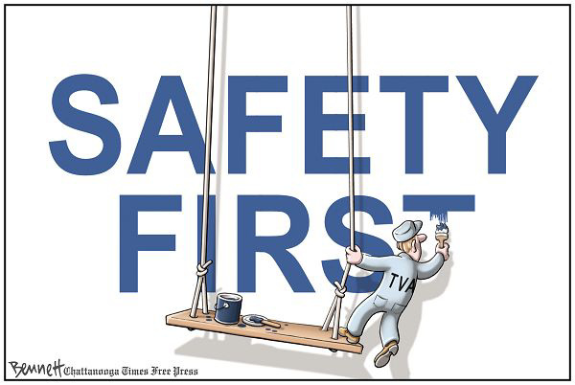

***Code Red: Serious Injury or Fatality***

**When a serious injury or fatality has occurred you must follow these instructions:**

I. Contact persons who need to know:

A. By Radio:

1. Radio the Camp Director and Med Shed immediately that there has been a CODE RED (no other information detailing the accident should be provided).

2. Identify yourself and the victim

3. Identify location of accident

4. Inform all others to immediately go to the Pavilion

##### B. Crisis Management Team

1. Camp Director and Assistant Director (contact the following stating CODE RED)
2. Director of the Med Shed
3. Assistant Director of the Med Shed
4. Director of Security
5. Assistant Director of Security
6. Gopher
7. Media Liaison/Hostess

II. Procedure

A. At the site of the incident:

1. Identify CODE RED.

2. Unit Leader and one additional staff member to stay with victim.

3. Remaining staff and campers proceed carefully to Pavilion.

B. Camp Director and Director of Security:

1. Camp Director immediately goes into Code Red Status and relinquishes her regular camp duties to the Assistant Director.
2. The Camp Director and the Director of Security immediately go to the incident site.
3. Camp Director calls authorities (911), parents/guardian of the victim, camp attorney, insurance agent and accreditation chairman. Camp Director is the only person to contact parents and/or guardian of the victim. This is done immediately or as soon as possible. The Camp Director may decide to contact other persons such as the victim’s physicians and/or nurses to assist in helping the family.
4. The body of the victim is not moved from the scene unless there is any chance of resuscitation, which would be handled by the emergency personnel response. However, should the victim’s death be caused by illness, the Med Shed Director and the Camp Director can accompany the body to the Med Shed.

5. Statements made:

a. No statements (except the official press release) are made to anyone except to the police.

1. Exercise care so that no statements are made orally or in writing that could be interpreted either as an assumption or rejection of responsibility for the incident.
2. Limit statement to the facts.
3. Avoid opinions.
4. Do not give out names of staff or campers to the media.

C. Roles Change:

1. Camp Director handles all emergency calls and makes assignments relating to the incident.
2. Assistant Director becomes Camp Director while Camp Director is in Code Red Status.
3. Director of Security handles all media. Only one (1) story should be presented to the media as an official statement/press release and should be reviewed and approved by the camp attorney. The Director of Security ensures that no campers or staff is interviewed by the media at random. Interviews are only allowed in the presence of the Director of Security.
4. Asst. Director of Security mans the front gate and prevents entrance of anyone into camp until notified by the Director of Security. Asst. of Security ensures the “Gopher” properly escorts all persons (only authorities, parents, and eventually media) entering Camp.
5. Gopher escorts all media to the Lodge unless the incident occurred there and then to the Rec Hall. The Gopher and Media Liaison/Hostess stay with the media at all times until the Director of Security arrives to speak to the media. The Gopher also brings the victim’s parents to the Med Shed immediately upon arrival to meet Camp Director, Director of Security, and Med Shed Director.

D. All others:

1. All counselors and staff will be informed of the CODE RED.
2. Cabin groups leave area and proceed to Pavilion.
3. Assistant Director will provide activities for the cabin groups with assistance from counselors and other staff members.
4. No statements are made about the incident except to the police and in the presence of the Director of Security.

### III. When Crisis is Over

A. Roles return to original status.

B. Camp Director and Med Shed Director

Inform the following people about the incident in the following order:

1. Camp Staff

2. All campers’ parents (The Camp Director and Med Shed Director will contact each camper’s parent or guardian)

3. Campers

a. Inform the victim’s cabin first (if victim is a camper)

b. Inform remaining campers together

c. Provide necessary time for questions and counseling. Bring in outside assistance for counseling if needed.

C. Documentation.

1. Complete incident reports.

2. Keep records of everything:

a. Telephone calls (that are made to and from Camp and with whom, what said, what time)

1. Press release

c. List of all witnesses and their statements

***Universal Precautions***

As a camp counselor, you should be aware of the risk of infection and observe the following measures to avoid and control infection between people.

1. Gloves are to be worn when you are:
   1. Touching blood, body fluids tinged with blood, mucous membranes, and non-intact skin of all persons.
   2. Handling items/surfaces soiled with blood
   3. Cleaning up spills
   4. Changing all diapers
2. If contact with the above occurs and no gloves are available, wash hands with soap and water thoroughly.
3. Gloves will be kept in each cabin for use as needed (i.e., when changing soiled bed linens).
4. All staff members should have a pair of gloves in pockets or backpacks at all times. Gloves will be distributed by your Unit Leader.
5. Spills on hard surfaces will be cleaned with a mixture of bleach & water.
6. Report any incidents of human bites to the Med Shed personnel immediately.

**HANDWASHING**

* Crucial to the prevention of the spread of infection
* Hands should be washed often!
* Before meals
* Before working with a camper
* After changing a diaper or toileting a camper
* After wiping nose or mouth
* After caring for a camper that has an infectious disease
* After using the restroom
* After handling trash
* After contact with body fluids or blood
* After touching or handling animals
* Any other time hands become soiled

***Abuse Policy***

As a staff member, you should know that we make an active and committed effort to prevent child abuse. Child abuse may include but is not limited to:

* **Physical abuse**-includes any assault by a staff member upon an individual. This includes hitting, pushing, grabbing, or physically hurting an individual.
* **Sexual abuse**-proposing, engaging in sexual conduct, or exhibition with an individual. It includes any sexual conduct with an individual by a staff member with the intent to gratify the sexual desire of him/her or the individual.
* **Verbal abuse**-cursing, teasing, scolding, shouting, or threatening an individual. It includes verbal conduct by a staff member that demeans an individual.
* **Psychological abuse**-includes humiliation, harassment or threats of punishment.

1. Staff members are not permitted to be alone with individual campers. There is NEVER a time there should be less than 3 people in a group when a camper is present!

2. Adults and campers may not sleep together under any circumstances.

3. If a camper is injured and requires first aid, the medical staff, in the presence of another staff member, will examine the camper.

4. Campers are only released to their legal guardian or someone designated by their legal guardian in writing.

5. Campers may not be touched in areas of their bodies that would be covered by swimming suits.

6. Staff may not use physical punishment or verbally abusive comments, nor may they deny the necessities of care to any camper.

7. Staff must immediately report any signs of injury or possible signs of child abuse to a Director.

8. There will be no gossip concerning disclosures made by campers. Discussion of confidential matters is grounds for immediate dismissal.

***Procedures***



Trashy Tribe

For health, sanitation & comfort in group living, it is important that camp be kept as neat and clean as possible. Competition for the cleanest Tribe is secondary to sanitation & comfort.

Inspection will take place each morning. Cabins should be cleaned according to camp guidelines:

* Floors swept
* Living area straightened and free of clutter (beds made, clothes in suitcases or dirty clothes bags)
* Front porch swept
* Lights and air conditioners turned off
* Cleaning tools MUST be put back in place and in correct position.
* Interior of cabins as free of odor as possible

(More detailed instructions to follow)

* The TRASHY TRIBE AWARD will be named each day at dinner to the least clean tribe.
* The members of the TRASHY TRIBE group will be responsible for cleaning the dining pavilion tables that night.
* If all tribes follow the cleaning regiment, there will be no TRASHY TRIBE named.
* A watchful eye will be kept on each tribe throughout the day. The following will be assessed:

1. Camper and Counselor belonging in the cabin kept neat and tidy
2. Tribe tables and dining area clean from trash
3. Bathroom area picked up daily after use
4. Pods and break areas free from trash



Cabin Duty

* Cabin Duty is a time when the counselor is assigned to supervise the campers in his/her Pod during camper bedtime.
* Expect to be on cabin duty at least 1 time per week.
* Unit Leaders will draw names on Monday evening to select Pod duty for the week. The Unit Leader will try to have at least 5 counselors on duty depending on the number of counselors assigned to the Pod.
* The campers are to be checked at no less than 15 minute intervals. Check each cabin individually.
* People on duty are responsible for campers in each cabin in their Pod.
* Stay awake and alert while on duty. NO sleeping on duty.
* Noise inside & outside the cabin must be kept to a minimum. It is the responsibility of the counselor on duty to insure that the campers are given the opportunity to rest quietly.
* Send a runner or use duty walkie-talkie if there are any problems or concerns.
* Counselors on duty may take turns taking QUICK showers with the other counselors on duty in the same Pod.

NEVER LEAVE A CAMPER UNATTENDED IF THERE IS A MEDICAL CONCERN.

***Counselor Check-In***

***IMPORTANT:***

* Counselors are to report to camp on Monday by 5:00pm.
* Counselors must sign in as they arrive.
* Counselors must have signed applications, permission forms & agreements on file with UCP.
* All luggage is to remain outside until cabin assignments are issued.
* A Mini Pre-Camp will be held each Monday.

**Full Counselor Check-In Procedures**

1. Sign-In
   1. As counselors arrive, a leadership staff member will find their files and verify that we have all information needed:
      1. Signed application
      2. Signed agreement form
      3. Insurance information or **insurance waiver form**
      4. Verification of tetanus shot within last 10 years
      5. Camp Grace Release form
      6. CPR certification card
   2. If any of the above information is missing, forms will be filled out.
   3. Lack of CPR certification is acceptable, so long as it is obtained from at least 80% of the staff.
   4. Counselors will be given their cabin number assignment and a schedule for the week.
2. Health Screening (Nurses)
   1. Lice check
      1. A nurse or medic must perform a thorough lice check on every counselor.
      2. Counselors failing the mandatory lice check will be sent home immediately for treatment. They will be welcome back at camp once the nurse has determined they are completely nit-free.
   2. Nurse will discuss with each counselor and check for evidence of illness, injury, or communicable diseases/conditions, including temperature and whether the counselor has experienced nausea or vomiting within the last 24 hours. They will also verify and update any health history information the staff member has chosen to share to identify any medication, changes in health status, or special needs that may require follow-up.
      1. Minor concerns will be documented on an **incident report.**
      2. Should the nurse have any major concerns regarding a counselor’s health assessment, they will determine the proper course of action in consultation with the Camp Director.
   3. Counselors will turn any medications in to the nurse, who will keep them secure in the Med Shed. Any medical concerns, including needs for reasonable accommodations, will be discussed with the nurse.
3. The Director will contact any “no-show” counselors to confirm their status. Late arrival counselors must undergo the complete check-in.

After check-in, counselors are free to move into their cabins. Counselors will also have the opportunity to purchase Camp SMILE merchandise during check-in. *Daily volunteers must follow visitor check-in procedures and fill out a Voluntary Disclosure Statement.*

***Counselor Check-Out***

1. Counselors will attend a mandatory meeting on Saturday after all campers have gone.
2. Counselors will be dismissed only after cabins & grounds have been inspected and approved.
3. Lunch will be served on Saturdays.
4. Parents should pick up between 12:30 & 1:00 on Saturday.
5. Parents arriving early or before your cabin has been approved will be asked to wait. If there is a problem, parents should discuss it with one of the leadership team.
6. NO ONE will be allowed to leave before the final check out meeting!

***Camper Check-In***

***IMPORTANT:***

1. Campers should arrive between 8-11 am Tuesday.
2. All counselors should be stationed outside of the lodge or in assigned places so as to be within hearing distance upon camper arrival.
3. Campers will be greeted at their vehicles by the Leadership team. Counselors will be called for as their campers arrive.

Campers Arriving With Parents:

* If parents choose valet parking, counselors should help unload luggage and come to check in with parents and campers.
* If parents choose to park their cars, counselors should help unload luggage and then supervise campers outside the lodge until parents return.

Campers Arriving on Buses/Vans:

* Counselors should help unload luggage and then bring campers through check in with Matrisza or Molly. Medication will be taken care of by the group home leaders.

1. **All luggage should be checked for identification and unloaded at the luggage station where it will be tagged according to cabin assignments.**
2. Upon arrival at the cabin, a rapid assessment of the camper’s luggage should be done. What to look for: Enough clothes to last the week, sheets/pillows/blankets, toilet articles, enough diapers (if applicable), towels/washcloths (at least 2 sets). If it is found that the camper is lacking something, the counselor should report it immediately to the Unit Leader in charge.
3. After initial assessment is found to be satisfactory, the counselor should continue to complete the inventory, make the bed & begin to establish a relationship with your camper.

**COUNSELOR SHOULD:**

* Ask questions of parent or guardian if something is unclear.
* Ask parents or person arriving with the campers about:
  + Use of special equipment – braces, wheelchairs, adaptive eating equipment, etc.
  + How the camper communicates wants, needs or pain.
  + Any special adaptation, problem, concern noted on the application.

**Full Camper Check-In Procedures**

1. Sign In (Director)
   1. As campers and their caregivers arrive, Director will pull their files and verify that we have all information needed:
      1. Application with signature of guardian
      2. Insurance information or **insurance waiver form**
      3. Verification of tetanus shot within last 10 years
      4. Camp Grace Release form
   2. If any of the above information is missing, forms will be filled out.
   3. Director will assign each camper to a nurse.
2. Review of Camp Grace Release form for high ropes participation (Camp Grace Representative)
   1. Camp Grace Representative will review each camper’s Camp Grace Release form as they arrive.
   2. Camp Grace Representative will discuss any concerns regarding camper’s high ropes participation with the camper and their parent/guardian and will determine whether they qualify for participation.
   3. Campers who appear to fall outside of the weight limit for the high ropes course (6 years old and 60 to 250 lbs) will be weighed to verify whether they qualify for participation.
   4. *Note: Camp SMILE follows a “Challenge by Choice” policy. Permission must be granted by the camper for participation. Verbal permission from the camper may be gained and/or changed at any point prior to the high ropes activity period.*
3. Health screening (Nurses)
   1. Lice check
      1. A nurse or medic must perform a thorough lice check on every camper.
      2. Campers failing the mandatory lice check will be sent home immediately for treatment. They will be welcome back at camp once the nurse has determined they are completely nit-free.
   2. Completion of Health Assessment form
      1. Nurse will discuss with campers and parents/guardians and document bowel habits, temperature, evidence of illness, injury, or communicable diseases/conditions, as well as details of any special medical needs (i.e., seizure management, shunts, g-tubes, procedures) and whether the camper has experienced nausea or vomiting within the last 24 hours.
      2. Should the nurse have any concerns regarding a camper’s health assessment, she will determine the proper course of action in consultation with the Camp Director.
   3. Nurse will review the Medication Administration Record (MAR) of each camper in consultation with the camper and their parents/guardians. Any special medication needs or changes in medications, care, or health history will be documented.
   4. Medications will be collected and filed.
   5. Nurse will give each camper’s medication schedule to their counselor.
4. Parent information (Assistant Director)
   1. Assistant Director will greet each parent/guardian and provide the following information:
      1. Invitation to talent show with phone numbers of Director and Assistant Director
      2. Website for obtaining camp photos and sending emails for campers
      3. Survey to be returned at the end of the week
      4. Answers to any questions or concerns
5. The Director will contact the parents/guardians and/or emergency contact of any “no-show” campers to confirm their status. Late arrival campers must undergo the complete check-in.

Counselors accompany their campers and camper families during check-in. Parents and guardians will also have the opportunity to purchase Camp SMILE merchandise during check-in.

**Respite Weekend Check-In**

Respite Weekend check-ins will follow the above procedures. Item “2” (Camp Grace Representative station) may be omitted if the high ropes activity is not included during the weekend.

Camper Check-Out

* Inventories should be complete by the end of rest time Friday. Missing items should be reported to unit leaders and searched for completely. Items which could NOT be located should have a note written by the counselor apologizing for the loss of the item. Did your camper get a camp T-shirt? Make absolutely sure it is packed to go home. If it is missing, please tell your unit leader IMMEDIATELY!
* Items sent to the laundry should be accounted for and packed. Dirty clothes bags should be packed in the suitcases or tied to the outside of the suitcase.
* Did your camper bring their own personal bath chair? Collect it from the bathhouse, make certain it is labeled, and put it on the porch of your cabin.
* Pack your journals and arts and crafts (which will be delivered to you by your unit leader Friday night)
* Nurses will check out medications. **PLEASE ASK PARENTS TO VERIFY CAMPER MEDICATIONS HAVE BEEN PICKED UP FROM NURSES PRIOR TO LEAVING**.
* Re-label pillows and other items which might have had their labels removed. Make certain the name label is visible on the dirty laundry bag. See your UL for tape and sharpies.
* All camper belongings should be packed, labeled and placed on your porch BEFORE you go to breakfast on Saturday morning. Include 1 of _ bags on the label.
* All counselor belongings should be COMPLETELY packed and placed on the top bunk beds inside your cabins BEFORE you leave for breakfast on Saturday morning.
* Sweep cabins and porches BEFORE you leave for Breakfast.
* Take trash to the garbage cans in the middle of the pods BEFORE Breakfast; NO trash should be left in the cabin or on the porches.
* Camper luggage will be picked up and taken to lodge by designated luggage crew for parent pick up.
* All items borrowed from Camp Grace (i.e. Blankets, pillows, sheets, sleeping bags, etc.) should be checked back in with cleaning staff. All bed rails should be returned to the storage bucket on the front porch of the sick room.
* As parents/buses or vans arrive, a runner will notify you to bring your camper to their vehicle.
* Upon arrival at the vehicle, the counselor should remain with the camper until all luggage is accounted for and loaded, and the camper is inside the vehicle. Make sure that the supervisor in charge of loading specific vehicles has your camper’s name marked off his/her list.
* The counselor is not to discuss problem situations with the parent/driver. Any questions involving problems should be directed to a Director. (Further detailed instructions will follow).
* Inform parents/drivers of missing personal items.
* Give your camper an extra high five to let them know how much you have enjoyed them. Thank a counselor for their help. Congratulate yourself for making a difference!

***Pavilion Dining Procedures***

* Counselors & campers come into pavilion and sit at assigned tables.
* Campers with specific dietary needs will be given special plates. Special plates will be given out before Tribes are called to eat.
* Tables will be called one by one to go through the line. Counselors should listen for your tables before getting in line with your campers.
* All campers should be allowed to carry their own trays if possible. At times, it may be necessary to assist the camper, but camper should be required to be as self-sufficient as possible.
* No camper should be allowed to return for a second plate unattended by their counselor.
* Campers should be closely monitored by their counselor when handling self-serve items.
* AT NO TIME should a camper pour his/her own coffee.
* All trays must be taken from the table and disposed of in the required manner. (This will be demonstrated to you). Allow campers to dispose of their own trays if capable, with your guidance.
* You should remain in the dining hall until after announcements and until you are dismissed.

Large Group Seating Procedures

* Space is provided at the front for wheelchairs, walkers & campers with visual impairments.
* Seats should fill from front to back.
* When leaving the activity, wheelchairs, walkers & campers with visual impairments will exit first. All others will remain seated until dismissed.

Camp Trolley Procedures

* A transportation system is provided for campers with mobility issues, visual impairments, & others designated by the Director.
* If your camper is capable of walking, walk when you can. It should not always be necessary for those who can walk to use the transportation provided.

Curfew

1. Curfew is 11:30 p.m. This includes nights on which meetings are scheduled.
2. At curfew, all counselors are expected to be in their cabin with lights out.
3. Showers, restroom, etc… are expected to be done prior to curfew.
4. If you must use the bathroom after lights out, do so quietly without waking others in your cabin. Return directly to your cabin when finished and be aware that there will be a security guard walking rounds through the night to ensure your safety.
5. **GO TO BED! GO DIRECTLY TO BED! DO NOT PASS GO! DO NOT COLLECT ANYTHING BUT SLEEP!**

Snack Procedures

Snacks will be available at the Rec Hall and at the Pavilion after the second and sixth activity periods. Go to whichever location is closest to your next activity. Special plates will be available for campers who need them. Remember to get your camper a snack first and to make sure there are enough snacks for everyone before serving yourself. One snack per person.

***Break Procedures***

Each counselor will be given night time breaks with the exception of 1 duty night. Break begins when your Unit Leader dismisses you and ends at 11 p.m. This means showers, bathroom, and tooth brushing, must be done before 11 p.m. Night time break area is limited to the Recreation hall, and other areas provided for you by the leadership team on nights of special counselor events. **NO** visiting people on duty in the Pods during your break.

***Rest Time Procedures***

Rest time is from 1:00 to 2:10pm on Tuesdays and from 1:45 to 3:10 Wednesday-Friday. No activities are scheduled during this time. Counselors are to be with their campers in their cabins during rest time. “Rest time” does not mean you are “off duty”—you are still responsible for supervising your camper. Some campers may need to stay active during rest time; if this is the case, some activity areas are available. Counselors should also have cards, coloring books, or other small activities on hand to entertain campers during rest time if they do not wish to take a nap. Make sure you are never alone with your camper.

***Lost Items***

* Lost and Found items should be brought to the Pavilion and placed on the head staff table. (example, items left at the lake)
* At each meal the lost items will be shown for counselors to claim.
* In order to retrieve a lost item, the counselor may be asked to sing a short song or display a personal talent for the group.
* Not claiming lost camper items will result in disciplinary counseling.

***ALWAYS KEEP UP WITH YOUR & YOUR CAMPERS BELONGINGS***

Inventory

* Inventory sheets will be provided at each mini pre-camp by your Unit Leader.
* Inventory sheets are to be completed upon arrival to cabin on Tuesday.
* Unit Leaders will check your inventory to ensure that you got everything and were descriptive enough.
* It is imperative that all of the camper’s clothes and belongings are located and returned to the camper’s luggage at the end of the week. Use the inventory sheet to make sure all items are accounted for.
* The Unit Leaders will collect the inventory sheets on Tuesday and store them until Friday, at which time they will be returned to the counselor to check and pack.
* Once you have obtained all the items on the inventory sheet, your unit leader will go over your inventory with you, making a list of any missing items. When complete, the inventory sheets should be initialed by the Unit Leader & placed inside the luggage to be sent home.
* You should try diligently to locate missing items. These items should be marked as “missing” on the inventory sheet. A list of missing items should then be made and turned in to the Director in charge of camper affairs. The list should include camper name, counselor name & a detailed description of each missing item.

***TREAT CAMPER BELONGINGS AS IF THEY WERE YOUR OWN***

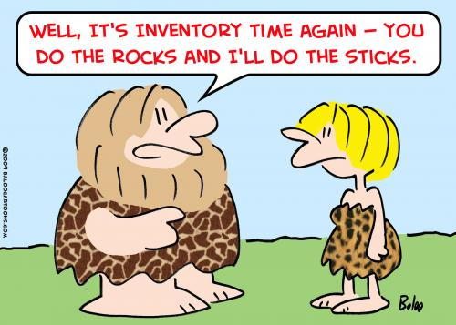

**CAMP SMILE INVENTORY LIST**

Camper: ___________________________ Counselor: __________________________

I.D. Mark Used: _____________________ Cabin: ______________________________

|  |  |
| --- | --- |
| **Item** | **Description, Color, Size** |
| Bras ___  Qty: _____ | 1. 3.  2. 4. |
| Socks ___  Qty: _____ | 1. 5.  2. 6.  3. 7.  4. 8. |
| Pants/Skirts/Dresses ___  Qty: _____ | 1. 4.  2. 5.  3. |
| Shorts ___  Qty: _____ | 1. 5.  2. 6.  3. 7.  4. |
| Shirts/Blouses ___  Qty: _____ | 1. 5.  2. 6.  3. 7.  4. |
| Underwear ___  Qty: _____ | 1. 4.  2. 5.  3. 6. |

**CAMP SMILE INVENTORY LIST**

| **Item** | **Description, Color, Size** |
| --- | --- |
| Blanket/Sleeping Bag ___  Qty: _____ | 1.  2.  3. |
| Sheets ___  Qty: _____ | 1. 3.  2. 4. |
| Pillow ___  Qty: _____ | 1.  2.  3. |
| Towels ___  Qty: _____ | 1. 4.  2. 5.  3. 6. |
| Wash Cloths ___  Qty: _____ | 1. 4.  2. 5.  3. |
| Swimsuit ___  Qty: _____ | 1.  2.  3. |
| Shoes ___  Qty: _____ | 1. 3.  2. 4. |

**TOILETRY ITEMS**

Toothbrush Yes ____ No ____

Toothpaste Yes ____ No ____

Razor Yes ____ No ____

Soap Yes ____ No ____

Shampoo/Conditioner Yes ____ No_____

Comb/Brush Yes ____ No ____

Deodorant Yes ____ No ____

Sunscreen Yes ____ No ____

Bug spray Yes ____ No ____

Lotion Yes ____ No ____

Other Yes ____ No ____

Laundry

* Washers & Dryers are available for campers only.
* A camper’s clothing should be laundered ONLY if they are soiled or clean supply is depleted.
* Clothes that are soiled should be rinsed out before being taken to the laundry and marked as TOXIC.

**PROCEDURE:**

* If your camper should run out of clothing, estimate what they will need to get through the week. It should not be necessary for a camper’s entire inventory to be cleaned.
* Clothing to be washed should be placed in a plastic bag & clearly marked with the camper & counselor names and cabin number.
* A laundry list (available from your Unit Leader) should be completed with detailed descriptions of soiled laundry & placed inside the bag.
* The bag should then be put in the basket on your Unit Leader’s porch.
* The clothing will be returned to you at which time you should thoroughly compare the clothing inside the bag to the laundry list, making sure everything is there.
* If something is missing, report it immediately to your Unit Leader.



LAUNDRY LIST

**TOXIC:** YES or NO-Please circle

CAMPER:________________________

COUNSELOR:____________________

CLOTHING IN BAG:

SHIRTS: Total #:________

____________________________________________________________________________________________________________________________

SHORTS: Total #:________

____________________________________________________________________________________________________________________________

PANTS: Total #:________

____________________________________________________________________________________________________________________________

OTHER:

_______________________________

_______________________________

CABIN # & TRIBE:_________________

UNIT LEADER:____________________

UNDERWEAR: Total #:_________

____________________________________________________________________________________________________________________________

SOCKS: Total #:_________

____________________________________________________________________________________________________________________________

SHEETS: Total #:________

____________________________________________________________________________________________________________________________

**Please remember to place this list on the outside of the dirty clothes bag**

***Horseback Policies and Procedures***

1. The maximum **weight limit** for participating in horseback riding is **225 pounds.**
2. Do not run, clown around or shout around the horses. ***No horseplay!*  ;)**
3. Campers go to the stable area only under adult supervision. Campers are **never** permitted to go into stalls.
4. Staff will perform daily **safety checks** on tack before the first group rides each morning. Each horse will be checked for physical soundness daily. Before each rider mounts, the cinch and stirrups are checked and each rider is checked for helmet, pants, and approved shoes.
5. Riders will be instructed in walking around a horse and keeping the **proper distance** from the back of the horse.
6. Riders will keep one length between their horse and the horse in front of them. On trail rides, they will stay in line.
7. **At least 2 staff members** will accompany riders at all times. Camper groups will be no more than 8-10 campers. On trail rides, one staff member is at the head of the line and one at the back of the line.
8. Each rider will be provided long pants (if not already wearing long pants), a helmet, and must wear **approved (closed toe) ­shoes**.
9. **All** campers and staff members under 18 are **required** to wear a helmet. Those over 18 may elect to sign an assumption of risk waiver.
10. All participants will be evaluated and classified according to **riding ability**. All horses, equipment, and activities will be suitable for beginners.
11. **Emergency Procedures**:
    1. **Fall from a Horse** – In case of a fall from a horse, all campers will stop and remain mounted. One staff member will assess the extent of the injury. If necessary, the other staff member will return to the stables to call the MedShed and return with appropriate help.
    2. **Kick by a Horse** – Ice will be applied and the participant will be sent to the MedShed for evaluation.
    3. **Runaway Horse** – All other riders will stop and stay mounted. Do NOT chase the horse. Almost always, the horse will return to the other horses immediately. If that does not happen, campers and one staff member will return to the stables. The remaining staff member stays in the area to locate the horse. If the runaway horse and staff member do not return within 10 minutes, staff will notify the Camp Director.
    4. **Horse Steps on Foot** – Ice will be applied and the participant will be taken to the MedShed for evaluation.
    5. **Horse Bite** - If the skin is broken, the participant will be taken to the MedShed for evaluation.
    6. If transportation is needed, the staff will call for a designated vehicle. If transportation is needed along the trail, the designated four wheel drive vehicle should be requested.
    7. In all of the above emergency situations, an **accident/incident report form** will be completed and returned to the MedShed.
12. Only Horseback Staff may **feed** horses.
13. **Counselors** riding with campers must be approved by the horseback director.
14. Director has final say as to **horse/camper assignment**.
15. All **horseback staff** will receive orientation, training, and briefing when working with horses.
16. All riders will receive a safety orientation prior to riding that includes information listed on this sheet.

***Waterfront Policy***

1. NO ONE is allowed in the water, on the docks, or in the watercraft at any time outside of regularly scheduled activities and without a qualified guard present.
2. All participants in aquatic activities, including staff, should be oriented in safety regulations and emergency procedures before activity begins.
3. Certified guards must be present and in the correct guard/participant ratio whenever staff are swimming or using watercraft.

|  |  |
| --- | --- |
| **Participants** | **Guards/Lookouts** |
| 10 or less | 1 guard |
| 11-20 | 1 guard and 1 lookout |
| 21-30 | 2 guards and 1 lookout |
| 31-40 | 2 guards and 2 lookouts |
| 41-50 | 3 guards and 2 lookouts |
| 51-60 | 3 guards and 3 lookouts |
| 61-75 | 4 guards and 3 lookouts |

\**In addition to the above criteria, counselors are to remain* ***with*** *their campers in the water* ***at all times.***

1. All staff and volunteers must be trained in the following:
   1. Boarding and debarking
   2. Use of Personal Flotation Devices (PFDs)
   3. Self-rescue in case of capsize or swamping
2. **Properly fitted PFDs ARE TO BE WORN AT ALL TIMES BY EVERY PERSON (INCLUDING STAFF) USING A CANOE OR OTHER WATERCRAFT.** Lifeguards will assist in ensuring that all PFDs fit properly.
3. No running on docks or horseplay in the swim area.
4. No hanging on float lines.
5. No swimming underneath the docks.
6. When 4 whistles are blown, everyone must get out of the water immediately.
7. The “buddy system” will be in effect during camper free swim.
8. Campers must remain in their designated area based on their level of swimming ability.
9. All campers must wear a life jacket when swimming unless they pass the swim test (swim the length of the buoy or from one dock to the other).



***Conditions and Disabilities***

j0280515

General Information About Disabilities

**INTELLECTUAL DISABILITY**

**What is Intellectual Disability?**

Intellectual Disability is a term used when a person has certain limitations in mental functioning and in skills such as communicating, taking care of him or herself, and social skills. These limitations will cause a child to learn and develop more slowly than a typical child. Children with intellectual disability may take longer to learn to speak, walk, and take care of their personal needs such as dressing or eating. They are likely to have trouble learning in school. They will learn, but it will take them longer.

**What Are The Signs of Intellectual Disability?**

There are many signs of intellectual disability. For example, children with intellectual disability may:

* sit up, crawl or walk later than other children
* learn to talk later, or have trouble speaking
* find it hard to remember things
* not understand how to pay for things
* have trouble understanding social rules
* have trouble seeing the consequences of their actions
* have trouble solving problems
* have trouble thinking logically
* people with intellectual disability will function at different levels.
  + Some will be able to have some success in academics. Many will be able to live independent lives as adults. Others may need some monitoring or assistance in some areas.
  + Many people with intellectual disabilities have limited language ability. It is important to understand that typically they understand much more than they can express. Give them as many choices as possible.
  + At the lower end of functioning level, campers will probably require total assistance with grooming, feeding, toileting, etc. It is important to let these individuals participate to their maximum potential and to make as many choices as possible. Remember to be very enthusiastic even if their interaction with you may not be as obvious.

**Tips**

1. Encourage independence in your camper.
2. Break down jobs into small steps. Tell your child what to do, step by step, until the job is done. Demonstrate how to do the job. Help her when she needs assistance. Give your camper frequent feedback. Praise your camper when he/she has done well. Build your camper’s abilities.
3. Be patient! Remember, your camper learns at a slower pace!
4. Give time to process your directions. Your camper may be slower to respond to what he has heard.
5. When a camper does something right, let him/her know through very specific praise. Ex. “I like how you are tying your shoes by yourself.”
6. Be enthusiastic in all your activities.
7. Be as concrete as possible. Demonstrate what you mean rather than just giving verbal directions. Rather than just relating new information, show a picture.
8. Let your camper know what behaviors are expected in advance, and what the consequences are if other behavior is chosen. It is then her choice.
9. Remember not to get caught up in an argument. State the 2 choices and count to 3. Then calmly carry out the consequence.
10. The child is GOOD; the BEHAVIOR they choose may be bad.
11. A little humor goes a long way!

**DOWN SYNDROME**

**Definition**

Down syndrome is the most common and readily identifiable chromosomal condition associated with intellectual disability. It is caused by a chromosomal abnormality: for some unexplained reason, an accident in cell development results in 47 instead of the usual 46 chromosomes. This extra chromosome changes the orderly development of the body and brain. In most cases, the diagnosis of Down syndrome is made according to results from a chromosome test administered shortly after birth.

**Characteristics**

There are over 50 clinical signs of Down syndrome, but it is rare to find all or even most of them in one person. Some common characteristics include:

* Poor muscle tone(low muscle tone makes any physical activity 9 times as intense as for you & I)
* Slanting eyes with folds of skin at the inner corners (called epicanthal folds)
* Hyperflexibility (excessive ability to extend the joints)
* Short broad hands with a single crease across the palm on one or both hands
* Broad feet with short toes
* Flat bridge of the nose
* Short, low-set ears
* Short neck
* Small head
* Small oral cavity

Just as in the typical population, there is a wide variation in mental abilities, behavior, and developmental progress in individuals with Down syndrome. Their level of impairment may range from mild to severe, with the majority functioning in the mild to moderate range. Due to these individual differences, it is impossible to predict future achievements of children with Down syndrome.

It may be effective to emphasize concrete concepts rather than abstract ideas. Teaching tasks in a step-by-step manner with frequent reinforcement and consistent feedback has been proven successful.

**CEREBRAL PALSY**

**What is CP?**

*Cerebral Palsy* -- also known as CP – is a condition caused by injury to parts of the brain that control our ability to use our muscles and bodies. *Cerebral* means having to do with the brain. *Palsy* means weakness or problems with using the muscles. Often the injury happens before birth, sometimes during delivery, or soon after being born. CP can be mild, moderate or severe. Mild CP may mean a child is clumsy. Moderate CP may mean the child walks with a limp. He or she may need a special leg brace or a cane. More severe CP can affect all parts of a child’s physical abilities. A child with moderate or severe CP may have to use a wheelchair and other special equipment. Sometimes, children with CP can also have learning problems, problems with hearing or seeing (called sensory problems) or intellectual disability. Usually, the greater the injury to the brain, the more severe the CP. However, CP doesn’t get worse over time, and most children with CP have a normal life span.

**What Are The Signs of CP?**

There are three main types of CP:

* Spastic CP is where there is too much muscle tone or tightness. Movements are stiff, especially in the legs, arms and/or back. Children with this form of CP move their legs awkwardly, turning in or scissoring their legs as they try to walk. This is the most common form of CP.
* Athetoid CP (also called dyskinetic CP) can affect movements of the entire body. Typically, this form of CP involves slow, uncontrolled body movements and low muscle tone that makes it hard for the person to sit straight and walk.
* Mixed CP is a combination of the symptoms listed above. A child with mixed CP has both high and low muscle tone. Some muscles are too tight, and others are too loose, creating a mix of stiffness and involuntary movements.

Other terms used to describe the different areas of the body that can be affected by CP include:

* Diplegia – This means only the legs are affected.
* Hemiplegia – This means one half of the body (such as the right arm and right leg) are affected.
* Quadriplegia – This means both arms and legs are affected, sometimes including the facial muscles and torso.

**CP Tips**

The camper may find a variety of special equipment helpful. For example, braces (also called DAFOs) may be used to hold the foot in place when the child stands or walks. Custom splints can provide support to help a child use his/her hands.

Campers with CP may need what is known as assistive technology. Examples of assistive technology include:

* Communication devices, which can range from the simple to the sophisticated. Communication boards, for example, have pictures, symbols, letters or words attached. The child communicates by pointing to or gazing at the pictures or symbols. Augmentative communication devices are more sophisticated and include voice synthesizers that enable the child to “talk” with others.
* Computer technology, which can range from electronic toys with special switches to sophisticated computer programs operated by simple switch pads or keyboard adaptations.

1. Love and play with your camper. Treat your camper as you would a child without disabilities.
2. The “look” of CP can give the mistaken impression that a child who has CP cannot learn as much as others. Focus on the individual child and learn firsthand what needs and capabilities he or she has.
3. Be inventive. Ask yourself (and others), “How can I adapt this activity for this child to maximize active, hands-on participation?”
4. Assistive technology can mean the difference between independence for your camper or not. Go out of your way to use what is available to you.
5. Often times a camper with CP cannot move independently. Change his position frequently so he does not develop pressure sores.
6. Ask parents about the position she prefers to sleep in so you can place her in the correct position. Ask if she should be turned at night.
7. If the camper wears braces, ask parents how to put them on and how long they should be worn.
8. If the camper is in a wheelchair be sure to ask the parents to demonstrate how it works.
9. Remember your feeding and positioning and handling training and don’t be afraid to ask for help.

**SPINA BIFIDA**

**Definition**:

Spina Bifida means cleft spine, which is an incomplete closure in the spinal column.

**Characteristics**:

The effects of the most serious form of spina bifida may include muscle weakness or paralysis below the area of the spine where the incomplete closure (or cleft) occurs, loss of sensation below the cleft, and loss of bowel and bladder control. In addition, fluid may build up and cause an accumulation of fluid in the brain (a condition known as hydrocephalus). A large percentage of children born with spina bifida have hydrocephalus. Hydrocephalus is controlled by a surgical procedure called “shunting”, which relieves the fluid buildup in the brain. If a drain (shunt) is not implanted, the pressure build up can cause brain damage, seizures or blindness. Hydrocephalus may occur without spina bifida, but the two conditions often occur together.

Many children with spina bifida need training to learn to manage their bowel and bladder functions. Some require catherization, or the insertion of a tube to permit passage of urine.

In some cases, children with spina bifida who also have a history of hydrocephalus experience learning problems. They may have difficulty with paying attention, expressing or understanding language, and grasping reading or math.

Children with spina bifida usually need to learn mobility skills, and often require the aid of crutches, braces or wheelchairs.

**Tips**:

1. Never let the camper sit in one place for a prolonged time. This stops circulation and causes pressure sores. Encourage them to do wheelchair pushups.
2. Check the camper’s legs and buttocks every night just before break. Notify your Unit Leader if there are any red areas or blisters.
3. Check the campers diaper often and change it when necessary.
4. Provide the necessary help and privacy for the camper to catherize himself on time.
5. Notify the medical staff if the camper vomits, is unusually drowsy, complains of a headache or acts peculiar as these may be signs of a shunt malfunction and may signify a medical emergency.

**MUSCULAR DYSTROPHY**

**Definition**:

Muscular Dystrophy (MD) is a chronic, non-contagious condition manifested by weakness of the voluntary muscles with eventual involvement of the entire muscle system. It is progressive (i.e. it gets worse with age)

**Symptoms**:

Constant falling, difficulty in ascending stairs, a peculiar side-to-side waddling gait, great difficulty in rising from a lying or sitting position. There may be an increase in the size of the affected muscles, particularly in the calf. Depending on the progress and stage of the condition, a child may be ambulatory or confined to a wheelchair. Most children with MD require a wheelchair for mobility by 8 years of age.

**Tips**:

1. Most children with MD have normal intelligence and fairly good use of their hands and speech muscles. Be aware of his or her limitations but encourage the child to do as much for himself as he can.
2. Always check for pressure sores every night and report any red or tender areas to the medical staff.
3. These children may also have difficulty breathing. Always report any complaints of difficulties to the medical staff.

**DIABETES**

**Definition**:

Diabetes is the name for a group of chronic (lifelong) diseases that can be controlled but not cured as yet. It affects the way the body uses food in the normal digestive process. Sugars, starches and other foods are changed to a form of sugar called glucose. The blood stream carries this glucose to the body cells where with the help of insulin it is changed into quick energy for immediate use or stored for future needs. In diabetes, this normal process is interrupted.

Diabetes develops either because the body does not produce enough insulin or because what is produced cannot be used effectively by the body cell. When glucose is unable to enter the cells, it accumulates in the blood until some of the surplus is eliminated by the kidneys and is passed off in the urine. Too much sugar in the urine and in the blood are classic signs of diabetes. The high levels of sugar in the blood are thought to cause the eye and kidney damage to which diabetics are prone.

**Types of Diabetes:**

* Type I, Insulin Dependent: Occurs most often in children and young adults. It accounts for about 10% of all cases of diabetes. It usually appears abruptly in children and young adults and progresses rapidly. Because the pancreas produces little or no insulin, these patients must take daily injections to stay alive. In this type of diabetes, complications may develop more frequently than in other forms.
* Type II, Non-Insulin Dependent: Usually occurs in adults over 40 years of age. This is the most common form and accounts for nearly 90% of the total diabetic population. It is usually gradual in onset. In this type of diabetes, some insulin is produced by the pancreas, but due to a cell receptor defect, the insulin cannot be used effectively. Type II can often be controlled by diet and exercise, and in some instances, oral medications are also used. Problems related to the circulation and heart are common in this type of diabetes. This type has been linked to obesity and inactivity.
* Other types not likely to be found at camp: Gestational Diabetes (occurs during pregnancy), Impaired Glucose Intolerance (occurs when blood sugar levels are between normal and diabetic) and Secondary Diabetes (induced by drugs or chemical, pancreatic or endocrine disease)

**WARNING SIGNS OF INSULIN REACTIONS**

Paleness Perspiring Shaky Nervous Headache

Nausea Stomachache Mood changes Confusion Irritability

**IF AT ANY TIME YOU SEE ONE OR MORE OF THESE SIGNS, ESPECIALLY SWEATING WHILE INDOORS, GO IMMEDIATELY TO THE MEDIC STATION!!**

**EPILEPSY**

**Grand Mal Seizures (Major motor seizures)**

During a grand mal seizure, the person may fall to the ground and the body may jerk violently. The camper may salivate, vomit, turn blueish, and may lose bladder or bowel control.

Care:

1. Keep calm. There is nothing you can do to stop a seizure once it has started.
2. Ease the person to the floor. Put something soft under the head. Don’t try to restrain the person.
3. Remove nearby objects that could injure the person.
4. Don’t touch their mouth during the seizure
5. Turn the head to left side, if possible to release saliva and prevent choking if he or she vomits.
6. Let the person rest afterward, if necessary, then encourage him to resume activities.

**Petit Mal Seizures (Minor motor seizures)**

These seizures last only a few seconds, but can occur frequently. Some characteristics are blank staring, head dropping, rapid eye blinking, day dreaming, and rigid extension of one or more extremities.

Care:

1. No special care is needed. Be aware that the person may not hear you speak during a seizure. If you were giving instructions, repeat the instructions again after he has come out of the seizure. You can be sure he is out of the seizure if he responds to his name.

**Tips**:

1. If a camper brings a helmet, be sure he wears it as directed.
2. Rest is very important; being over-tired can trigger a seizure.
3. Make sure your camper does not get overheated during activities.
4. It is of the **UTMOST IMPORTANCE** that campers with seizures get their medication on time.
5. Remain with the camper until the seizure is over.
6. If a camper spits up his medication, notify the medics immediately.
7. Do not allow a camper with seizures to be on a top bunk or climb to high places.
8. Never let campers with seizure
9. s swim alone.
10. Be sure to avoid stimuli that trigger seizures (i.e. flashing light, extreme fatigue).
11. Always time the seizure. A grand mal lasting 4-5 minutes may constitute an EMERGENCY.
12. It is physically impossible to swallow your tongue!!! This is a myth. The tongue is a muscle and is only contracting into the opening of the throat. Don’t ever put your fingers in the mouth of someone having a grand mal! It sounds much worse than it actually is.
13. Always report a grand mal seizure to your Unit Leader or Directors.
14. Always ask the parents what triggers the seizures, how they handles it while it occurs, and how often they happen!

**DEAFNESS AND HEARING LOSS**

**Definition**:

Deafness may be viewed as a condition that prevents an individual from receiving sound in all or most of its forms. In contrast, a child with a hearing loss can generally respond to auditory stimuli, including speech.

People with hearing loss use oral or manual means of communication or a combination of the two. Oral communication includes speech, lip reading and the use of residual hearing. Manual communication involves signs and fingerspelling. Total Communication, as a method of instruction, is a combination of the oral method plus signing and fingerspelling.

Tips:

1. Always use your voice when singing or speaking to a hearing impaired person and encourage them to do the same.
2. DO NOT use sign language to campers who are on a strict oral program.
3. Utilize speech to the fullest by introducing new vocabulary involving the surrounding environment.
4. If a hearing impaired person does not understand you, rephrase your statement.
5. Always face the person when talking. Utilize good positioning and lighting so the person gets full view of your face.
6. Do not over-exaggerate your speech. Talk normally at a slightly slower than normal rate.
7. Have the person’s attention before talking.
8. Sometimes balance problems accompany hearing loss.
9. Encourage children to wear aids at all times except when swimming or participation in a very physical game or activity.
10. Check to see if aids are working properly by checking for dead batteries, checking for loose wires, ear molds kept clean, see that the aid is ON during the day and OFF at night, tell the child if the aid is squeaking or whistling due to possible improper fitting, volume too high, child is too close to reflecting wall or window, microphone is too close to amplifier.
11. Encourage them to answer for themselves.

**BLINDNESS/ VISUAL IMPAIRMENT**

**Definition**

The terms partially sighted, low vision, legally blind and totally blind are used to describe individuals with visual impairments. They are defined as follows:

* “Partially sighted” indicates some type of visual problem has resulted in a need for special attention.
* “Low vision” generally refers to a severe visual impairment, not necessarily limited to distance vision. Low vision applies to all individuals with sight who are unable to read the newspaper at a normal viewing distance, even with the aid of eyeglasses or contact lenses. They use a combination of vision and other senses to learn, although they may require adaptations in lighting or the size of print, and, sometimes Braille
* “Legally blind” indicates that a person has less than 20/200 vision in the better eye or a very limited field of vision (20 degrees at its widest point)
* Totally blind individuals learn via Braille or other non-visual media.

**Tips**

1. Most of a blind person’s knowledge is gained primarily through hearing and touching. Many blind children have some useful visual ability.
2. Whenever you are in activities with campers with visual impairments, take the time to talk about what you see.
3. Whenever possible, present the camper with visual impairment with concrete objects which can be touched and manipulated.
4. Stimulate the camper’s senses by letting him feel and smell nature when taking him hiking.
5. Help the child with visual impairment grow and mature by encouraging him to do things for himself and become more self-mobile. It may take longer. HAVE PATIENCE!!
6. Utilize activities involving body awareness and independent living.
7. In hiking or walking, do not lead by the arm. Allow them to take your elbow.
8. Acquaint person with camp the first day, and how he may find things independently.
9. Do not allow self-stimulation – poking eyes, rocking. Give gentle reminders or a hand on the shoulder.

**TRAUMATIC BRAIN INJURY**

**What is Traumatic Brain Injury?**

A traumatic brain injury (TBI) is an injury to the brain caused by the head being hit by something or shaken violently. This injury can change how the person acts, moves, and thinks. A traumatic brain injury can also change how a student learns and acts in school. The term TBI is used for head injuries that can cause changes in one or more areas, such as:

- thinking and reasoning

- remembering things

- paying attention

- solving problems

- thinking abstractly

- talking

- behaving

-walking and other physical activities

- seeing and/or hearing

- learning

The term TBI is not used for a person who is born with a brain injury. It also is not used for brain injuries that happen during birth.

**What are the Signs of Traumatic Brain Injury?**

The signs of brain injury can be very different depending on where the brain is injured and how severely. Children with TBI may have one or more difficulties, including:

* Physical Disabilities: Individuals with TBI may have problems speaking, seeing, hearing and using their other senses. They may have headaches and feel tired a lot. Their muscles may suddenly contract or tighten (this is called spasticity). They may also have seizures. Their balance and walking may also be affected. They may be partly or completely paralyzed on one side of the body or both sides.
* Difficulties with thinking: Because the brain has been injured, it is common that the person’s ability to use the brain changes. For example, children with TBI may have trouble with short-term memory (being able to remember something from one minute to the next, like what the teacher just said). They may also have trouble with their long term memory (being able to remember information from a while ago, like facts learned last month). People with TBI may have trouble concentrating and only be able to focus their attention for a short time. They may think slowly. They may have trouble talking and listening to others. They may also have difficulty with judgment.
* Social, behavioral or emotional problems: These difficulties may include sudden changes in mood, anxiety, and depression. Children with TBI may have trouble relating to others. They may be restless and may laugh or cry a lot. They may not have much motivation or much control over their emotions.

**Tips:**

1. Give the individual more time; Be patient!
2. Give directions one step at a time.
3. Show the individual how to perform new tasks.
4. Have consistent routines. This helps the individual know what to expect. If the routine is going to change, let the camper know ahead of time.
5. Realize that the camper may get tired quickly. Let the camper rest as needed.
6. Be flexible about expectations. Be patient.

**AUTISM**

**What is Autism?**

Autism Spectrum Disorder (ASD) is a neurological disorder that affects a child’s ability to communicate, understand language, play, and relate to others. ASD represents a distinct category of developmental disabilities that share many of the same characteristics.

The different diagnostic terms that fall within the broad meaning of ASD, include:

* Autistic Disorder
* Asperger’s Disorder
* Rett’s Disorder
* Childhood Disintegrative Disorder
* Pervasive Developmental Disorder Not Otherwise Specified (PDD-NOS)

While there are subtle differences and degrees of severity among these conditions, treatment and educational needs can be very similar for all of them.

A diagnosis of autistic disorder is made when an individual displays 6 or more of 12 symptoms across three major areas: a) social interaction, b) communication, and c) behavior. When children display similar behaviors but do not meet the specific criteria for autistic disorder (or the other disorders listed above), they may receive a diagnosis of Pervasive Developmental Disorder Not Otherwise Specified (PDD-NOS).

Characteristics often associated with autism are engagement in repetitive activities and stereotyped movements, resistance to environmental change or change in daily routines and unusual responses to sensory experiences.

**What are the Signs of Autism?**

Some or all of the following characteristics may be observed in mild to severe forms:

* Communication problems (e.g., using and understanding language)
* Difficulty relating to people, objects and events
* Unusual play with toys and other objects
* Difficulty with changes in routine or familiar surroundings
* Repetitive body movements or behavior patterns.

Children with autism or PDD vary widely in abilities, intelligence, and behaviors. Some children do not speak; others have language that often includes repeated phrases or conversations. Children with more advanced language skills tend to use a small range of topics and have difficulty with abstract concepts. Repetitive play skills, a limited range of interests, and impaired social skills are generally evident as well. Unusual responses to sensory information- for example, loud noises, lights, certain textures of food or fabrics- are also common.

**Tips**

1. Be mindful to interact with and teach your camper in ways that are most likely to get a positive response. Learn what is likely to trigger melt downs for your camper so you can try to minimize them.
2. Be patient and stay optimistic!
3. Make sure directions are given step-by-step verbally, visually, and by providing physical supports or prompts, as needed by the camper. Campers with autism spectrum disorders often have trouble interpreting facial expressions, body language and tone of voice. Be as concrete and explicit as possible in your instructions and feedback to campers.
4. Find out what the camper’s strengths and interests are and emphasize them. Tap into those avenues and create opportunities for success. Give positive feedback.
5. If behavior is a significant issue for the camper, seek help from Unit Leaders and Directors to understand the meanings of the behaviors and to develop a unified, positive approach to resolving them.
6. Have consistent routines and schedules. When you know a change in routine will occur, prepare the camper by telling them what is going to be different and what to expect or do. Reward campers for each small success.

**ATTENTION-DEFICIT/HYPERACTIVITY DISORDER**

**What is AD/HD?**

Attention Deficit/ Hyperactivity Disorder (AD/HD) is a condition that can make it hard for a person to sit still, control behavior and pay attention. These difficulties usually begin before the person is seven years old. However, these behaviors may not be noticed until the child is older.

Doctors do not know just what causes AD/HD. However, researchers who study the brain are coming closer to understanding what may cause AD/HD. They believe that some people with AD/HD do not have enough certain chemicals (called neurotransmitters) in their brain. These chemicals help the brain control behavior.

**What are the Signs of AD/HD?**

There are three main signs or symptoms of AD/HD. They are:

1. Problems with paying attention.
2. Being very active (called hyperactivity).
3. Acting before thinking (called impulsivity).

**Inattentive Type**: Many children with AD/HD have problems paying attention. Children with the inattentive type of AD/HD often:

* Do not pay close attention to details
* Can’t stay focused on play or school work
* Don’t follow through on instructions or finish school work or chores
* Can’t seem to organize tasks and activities.
* Get distracted easily.
* Lose things such as toys, school work and books.

**Hyperactive-Impulsive Type**: Being too active is probably the most visible sign of AD/HD. The hyperactive child is “always on the go”. These children also act before thinking (called impulsivity). For example, they may run across the road without looking or climb to the top of very tall trees. They may be surprised to find themselves in a dangerous situation. They may have no idea how to get out of the situation.

Hyperactivity and impulsivity tend to go together. Children with hyperactive-impulsive type of AD/HD often may:

* fidget and squirm
* get out of their chairs when they’re not supposed to
* run around or climb constantly
* have trouble playing quietly
* talk too much
* blurt out answers before questions have been completed
* have trouble waiting their turn
* interrupt others while they’re talking
* butt in on the games others are playing.

Combined Type: Children with the combined type of AD/HD have symptoms of both of the types described above. They have problems with paying attention, with hyperactivity, and with controlling their impulses.

These behaviors can cause a child to have real problems at home, at school, and with friends. As a result, many children with AD/HD will feel anxious, unsure of themselves, and depressed.

**Tips**

1. Praise your camper when he or she does well. Build your camper’s abilities. Talk about and encourage his or her strengths and talents.
2. Be clear, be consistent, be positive. Tell your camper what he or she should do, not just what he shouldn’t do. Be clear about what will happen if your camper does not follow the rules. Have a reward program for good behavior. Praise your camper when he or she shows the behaviors you like.
3. Learn about strategies for managing your camper’s behavior. These include valuable techniques such as: having a reward program, ignoring behaviors, natural consequences, and logical consequences. Using these strategies will lead to more positive behaviors and cut down on problem behaviors.
4. Clear rules and routines will help a camper with AD/HD. Have set times for specific tasks. Call attention to changes in the schedule.
5. Help campers with ADHD channel their physical activity. They are not misbehaving to make you mad – they need lots of movement. If you are going to a sitting activity you might consider running laps first.
6. Make sure directions are given step by step, and that the camper is following the directions. Many students with AD/HD also benefit from doing the steps as separate tasks.

**SPEECH AND LANGUAGE IMPAIRMENTS**

**Definition**

Speech and language disorders refer to problems in communication and related areas such as oral-motor function – sucking, swallowing, drinking, and eating. These delays and disorders range from simple sound substitutions to the inability to understand or use language or use the oral-motor mechanism for functional speech and feeding. Some causes of speech and language disorders include hearing loss, neurological disorders, brain injury, intellectual ability, drug abuse, physical impairments such as cleft lip or palate, and vocal abuse or misuse. Frequently, however, the cause is unknown.

**Characteristics**

A child’s communication is considered delayed when the child is noticeably behind his or her peers in the acquisition of speech and/or language skills, but this is not always the case. A language disorder is impairment in the ability to understand and/or use words in context, both verbally and nonverbally. Some characteristics of language disorders include reduced vocabulary and inability to follow directions. Children may hear or see a word but not be able to understand its meaning. They may have trouble getting others to understand what they are trying to communicate.

Technology can help children whose physical conditions make communication difficult. The use of electronic communication systems allow nonspeaking people and people with severe physical disabilities to engage in the give and take of shared thought.

**Definition**

People with severe disabilities are those who traditionally have been labeled as having severe to profound cognitive impairments or mental retardation. The greater the severity or impact on an individual, there is a greater likelihood for increased need for support.

Often, individuals with a severe disability require ongoing, extensive support in more than one major life activity in order to enjoy the quality of life available to people with fewer or no disabilities and to participate in integrated community settings. They may also have additional significant disabilities, including movement difficulties, sensory losses, and/or behavior problems.

**Characteristics**

People with severe or multiple disabilities may exhibit a wide range of characteristics, depending on the combination and severity of disabilities and the person’s age. There are, however, some traits they may share, including:

* Limited speech or communication
* Difficulty in basic physical mobility
* Tendency to forget skills through disuse
* A need for support in major life activities (e.g., domestic, leisure, community use, vocational)

A variety of medical problems may accompany severe disabilities. Examples include seizures, sensory loss, hydrocephalus and scoliosis.

**DEMENTIA**

**Definition**

A chronic or persistent disorder of the mental processes caused by brain disease or injury and marked by memory disorders, personality changes, and impaired reasoning.

**Characteristics**

Progressive memory loss/ confusion

Inability to stay focused

Impaired reasoning

Behavior problems such as stripping & hitting

Impaired sensory & visual perception

May be possessive of items

Sundowner’s Syndrome: occurs in the evening and is marked by behavior changes, anxiousness, sadness, agitation or fear

**Tips**

May need frequent reminders (who, what, when, where)

Talk in concise sentences with clear, step-by-step instructions

Remind them of the task at hand

Provide assistance when changing terrain or using stairs

Prepare the person for transitions by give 5 minute warnings

Talk about any changes in schedule

Smile when talking to the person

Be reassuring

***Communication***

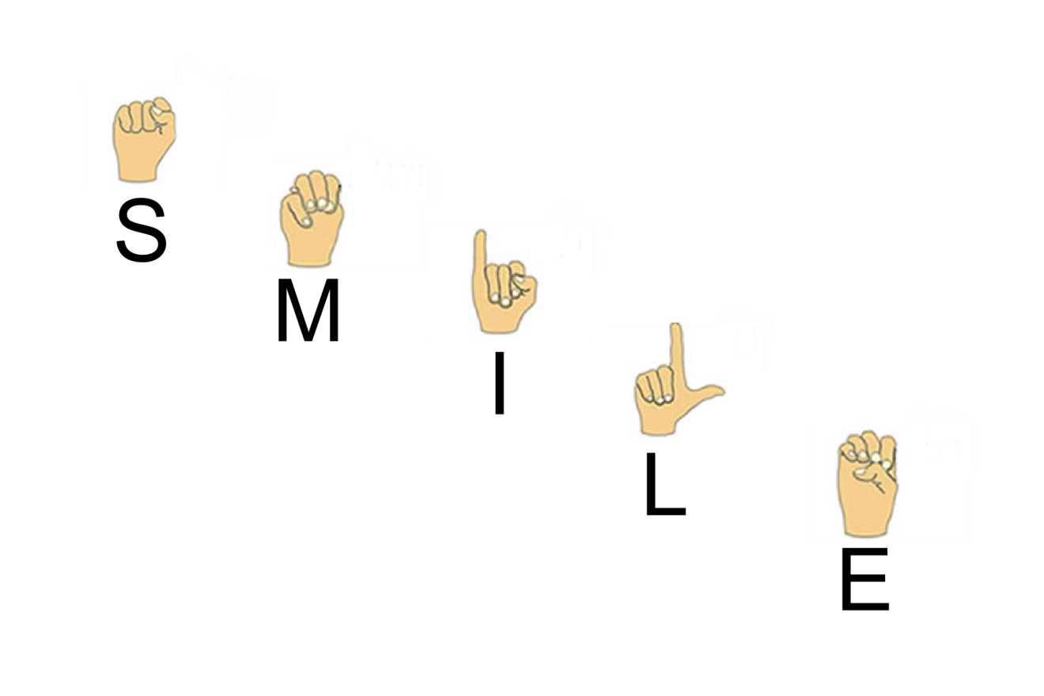

**COMMUNICATION**

**Definition**

A giving or exchanging of information, messages, etc. Communication can be verbal or non-verbal.

**Types of Language Ability**

1. Expressive Language – the ability to use words, signs, picture symbols, communication devices, etc. to convey what you know, think, want.
2. Receptive Language – what you understand of what other people say. Often what a camper can understand is much more than what he or she can express. Because of this, we need to be good at understanding nonverbal communication.

**Types of Non Verbal Communication**

1. Gestures & Body Language – body movements and sounds used to convey a meaning known to the camper. This type of communication is very important for campers that have limited language. An example of this is a child with autism that is non-verbal may clinch their fist and teeth or point to show fear. It is essential to take into account all areas of the environment.

Here are some examples:

* Crying
* Laughing
* Squirming
* Tracking with eyes
* Grimacing
* Smiling
* Biting
* Changes in body tone
* Screaming
* Eye contact
* Pointing
* Clenching teeth
* Staring
* Tantrums
* Tapping objects
* Pushing objects away
* Reaching
* Natural gestures

1. Augmentative Communication – a system other than talking or writing, which allows for functional expression of ideas and messages and encourages interactive communication. Just as you would not ignore your camper when he uses his voice to speak, do NOT discredit an augmentative voice. For some campers these devices are their one and only way to communicate with the world. Example: If they are repeatedly asking for m&m’s on the iPad, they truly want them and are not just playing around. You should just simply let them know whether or not this is an option right now.

Examples of Devices:

* Picture / Symbol Board
* Electronic Device with Voice or Written Output
* Communication Book
* iPad

1. Sign Language – a complete language (vocabulary) made up of hand gestures. These gestures are called fingerspelling and signs.

* Fingerspelling is a complete English alphabet and number system
* Signs represent words and ideas.
* It is not necessary to have a sign for every word. When in doubt about the sign for a word, fingerspell.

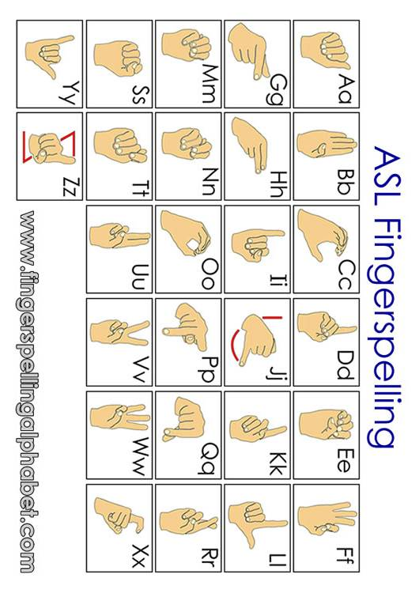

# BASIC SIGNS

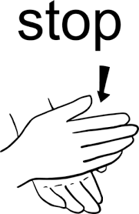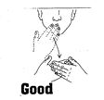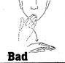

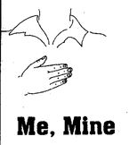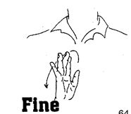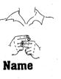

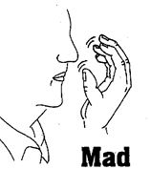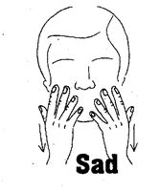

# BASIC SIGNS

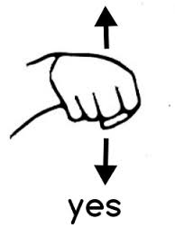

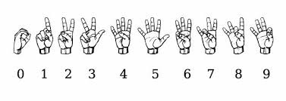

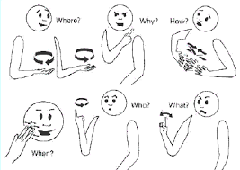

# FIRST AID

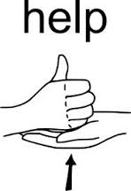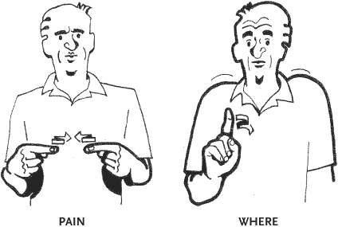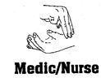

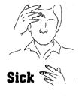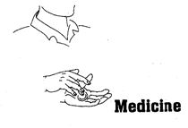

# TIME AND PLACE

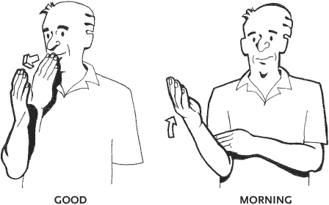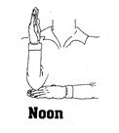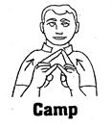

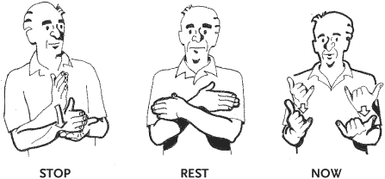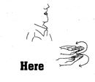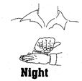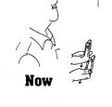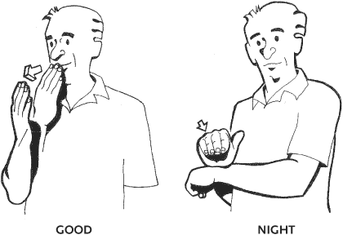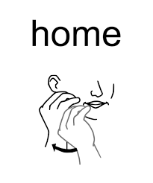

# FOOD AND DRINK

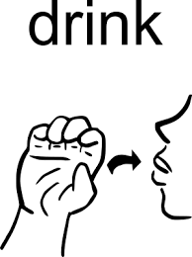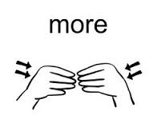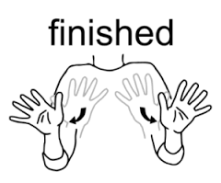

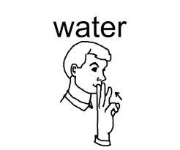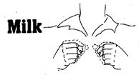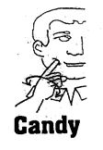

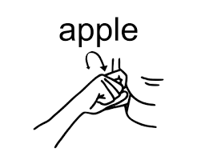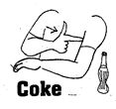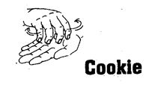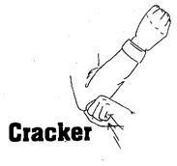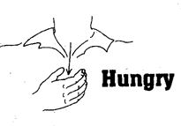

# CAMP ACTIVITIES

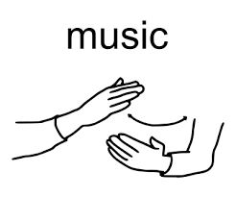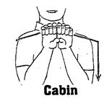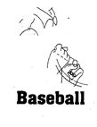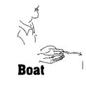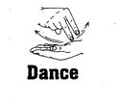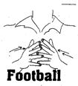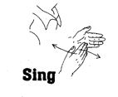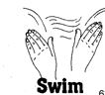

# DAILY LIVING

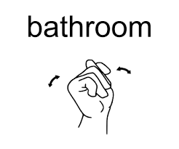 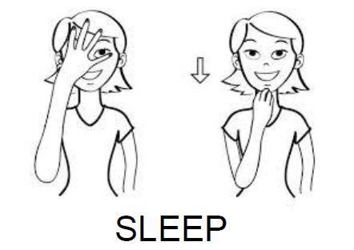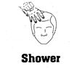

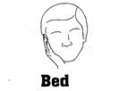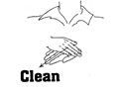

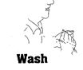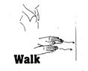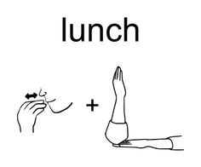

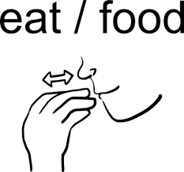

# PEOPLE

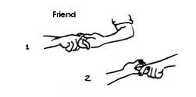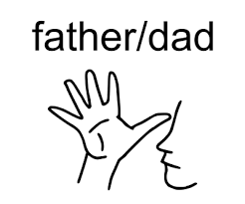

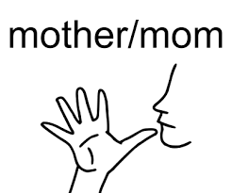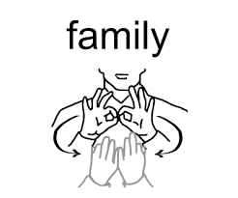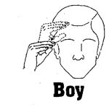

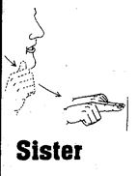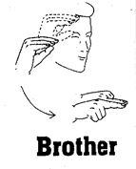

# ANIMALS

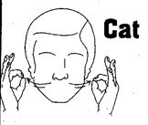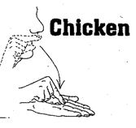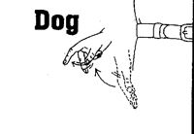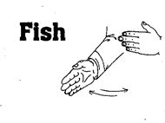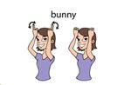

# MISCELLANEOUS

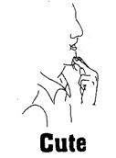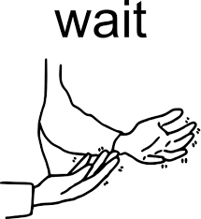

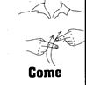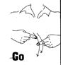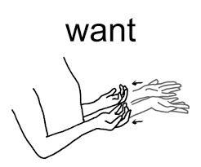

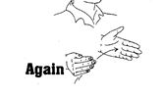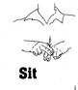

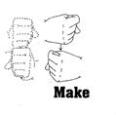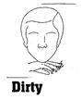\\sparkle0\Shared\old Shared\Camp\Camp Accreditation\Camp SMILE 2015 Accreditation\Sign Language Pics\From Old Handbook\Stand.JPG

Ten Commandments of Etiquette

1. When talking with a person with a disability, speak directly to that person rather than through a companion or sign language interpreter who may be present.
2. When introduced to a person with a disability, it is appropriate to offer to shake hands. People with limited hand use or who wear an artificial limb can usually shake hands.
3. When meeting a person with a visual impairment, always identify yourself and others who may be with you. When conversing in a group, remember to identify the person who is speaking.
4. If you offer assistance, wait until the offer is accepted. Then listen to or ask for instructions.
5. Treat adults as adults. Address people who have disabilities by their first name only when extending that same familiarity to all others present. (NEVER patronize people who use wheelchairs by patting them on the head or shoulders).
6. Leaning or hanging on a person’s wheelchair is similar to leaning or hanging on a person and is generally considered annoying. The chair is part of the personal body space of the person who uses it.
7. Listen attentively when you’re talking with a person who has difficulty speaking. Be patient and wait for the person to finish, rather than correcting or speaking for the person. If necessary, ask short questions that require short answers, a nod or a shake of the head. Never pretend to understand if you are having trouble doing so. Instead, repeat what you have understood and allow the person to respond. The response will cue you in and guide your understanding.
8. When speaking with a person in a wheelchair or a person who uses crutches, place yourself at eye level in front of the person to facilitate the conversation.
9. To get the attention of a person who is hearing impaired, tap the person on the shoulder or wave your hand. Look directly at the person and speak clearly, slowly and expressively to establish if the person can read lips. Not all people with a hearing impairment can read lips. For those who do lip read, be sensitive to their needs by placing yourself facing the light source and keeping hands, cigarettes and food away from your mouth when speaking.

10. RELAX. Don’t be embarrassed if you happen to use accepted, common expressions such as “see you later” or “did you hear about this” that seem to relate to the person’s disability.

***Behavior Management***

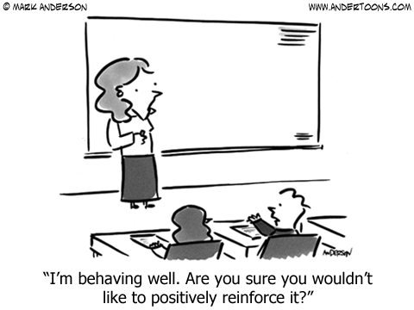

Behavior Management Policy

At Camp SMILE, you may encounter a variety of challenging behaviors from the campers. As a staff member you may have to work with an individual that bites, throws tantrums, screams, or refuses to cooperate. The next few pages were designed to give you suggestions and Camp SMILE approved procedures for dealing with challenging behavior.

Behavior modification involves a variety of techniques designed to reduce or eliminate challenging behavior & to increase socially acceptable behaviors. Not all techniques are appropriate for all situations or for all campers. If in doubt, ask the leadership team.

**POSITIVE REINFORCEMENT**

Positive Reinforcement is the first and most important technique. It should be used often, but at appropriate times. It should be used when a child shows the behavior you want to see.

Example: Tuesday & Wednesday nights a camper screams when it is time to take a shower. The camper does not scream on Thursday night; reinforce the camper with verbal praise and a hug.

Appropriate behavior is maintained when a child is told that what they are doing is pleasing to their camp friends. Be specific in your praise.

The reinforcement does not only have to be done verbally. Positive reinforcement can be conveyed in many ways. A smile, a touch, eye contact, or a hug are just as powerful in telling the campers that you approve of their behavior as verbal praise.

Every challenging behavior has an opposite behavior which should be encouraged & nurtured through positive reinforcement. Your camper is much more likely to behave in ways that please you if you tell them what you want them to do instead of what you don’t want them to do. Stay away from “No, Don’t, Stop”!

Example 1: “Walk” instead of “Stop” or “Don’t run”

Example 2: if a child frequently hits, that person should be lavishly reinforced for interacting with peers in appropriate ways; if a person whines, that person should be praised for speaking appropriately; if a person tends to disrupt a group activity, that person should be told how well he is participating.

**PREVENTION**

Prevention as it relates to behavior means heading off or avoiding bad behavior with your presence, your creativity, and your brains.

**Your Presence**: also known as physical proximity, this is always an excellent way to prevent behaviors you don’t like. Some campers may have problems with specific activities or transitions. If you are aware of specific problems, put yourself close to your camper & your presence alone will prevent many a bad situation.

Example 1: If your campers Joey & Johnny need water at different times and you know that Joey can be trusted 50 feet away from you but Johnny cannot, by staying close to Johnny you prevent having lost a camper, aggression toward another camper, etc.

Example 2: When you are passing notes in class and your teacher walks over and stands next to you while she lectures, what do you do? You stop your bad behavior.

**Your Creativity**: by keeping campers busy at and between activities you can prevent many challenging behaviors. When the campers have to wait – sing, play games, talk, walk, etc. If a camper gets bored, he is more likely to act out.

Example 1: If your camper can’t wait well, you might take a walk or count fish, or play hand games instead of waiting at your table to be called for dinner.

Example 2: If your camper is afraid of doctors and views the nurse as such, you know she is going to get upset when she realizes she is in the med line. You might choose to ask a friend to pick up her medicine for you while you & she sing songs 50 feet away from the med shed. You can then give her medicine to her without tantrums or fear.

Activities are created to benefit the majority. However, you may have a camper who finds the activity too difficult or too easy, causing frustration or boredom. Again, a little creativity goes a long way!

Example: Increase or decrease distance, use a ball that can be grasped more easily, KEYWORD: ADAPT.

**Your Brains**: By thinking ahead and planning for situations that will cause you trouble, by knowing your camper inside and out, and by providing well thought out choices, you can save yourself many problems.

Example 1: If you know that waiting in a line is difficult for your camper you might plan to play in the jump or take a Frisbee with you to toss until the line has gone down.

Example 2: When you know your camper really well you know what to avoid and what to encourage or substitute. If you know your camper is likely to tantrum when he has to get out of the lake but he loves chips, you might choose to have a bag in your backpack. You can then tell him “In 5 minutes we have to get out of the lake. Let’s eat some chips while we walk to your cabin.”

Giving choices can frequently prevent challenging behaviors because the camper feels that she has some control over what happens. The key is for both choices to be acceptable for you but to make the choice you’d prefer your camper to make to sound more appealing.

Example 1: Your camper doesn’t want to walk to her next activity and has fallen to the ground and won’t get up. You say “You can pick to get up and go to art (where we get to use paint) and we’ll sing “Mr. Sun” on the way or you can pick to stay on the ground and we’ll have to tell Matrisza, Martha & Kerry (who you love) that we were late.

Example 2: Your young camper runs away from you and refuses to play outdoor games with you. You can say “You can pick to come and hit the ball by yourself like a big boy, or I can help you!” This frequently works with the younger campers.

Remember that you must be able to follow through with both options so don’t threaten a consequence or offer a reward that you can’t deliver.

**TIME OUT**

Time Out is a technique that should be used sparingly and carefully. It should be used only after the camper has repeated the behavior more than twice & after you have explained to the camper that such behavior is unacceptable. Make sure the camper understands what you are telling him or her:

TIME OUT PROCEDURE

1. Calmly take the camper by the hand to time out area. (A time out area is simply a quiet place away from the group or whatever has triggered the unacceptable behavior). Firmly but quietly say “I cannot allow you to (be specific with behavior). You will have to sit here until I tell you that you can get up”.
2. Note the time and move away from the camper. Do not talk with or look at the camper during time out.
3. If other campers or counselors approach the time out area quietly tell them to leave. Explain “____” needs to be by himself for a few minutes.
4. At the end of the time, promptly go to the camper and say “You may get up now”. Do not lecture. The camper knows the reason for the isolation. To channel the camper into constructive behavior, you might suggest joining an on-going activity. Reinforce the camper as soon as possible for engaging in appropriate activity.
5. Sometimes over-stimulation occurs and is another reason for time out. Take the camper to a quiet, less stimulating area until he or she regains control.

TIME OUT LIMITS: Usually 1 minute per mental year is appropriate. More time than that and the camper is likely to forget why he or she is in time out.

Keep in mind that time out is not a punishment. Rather, it is time for them to calm down and think about what has happened. Sometimes aggressive behavior is a reaction to a general feeling of anger, anxiety, or unease, and time away from the situation can help the camper calm down.

**REDIRECTION** is a useful technique. This is distracting a camper from a negative behavior by offering something else that is more interesting and more appropriate.

Example1: A camper may be doing something unacceptable such as patting a counselor. Instead of acknowledging the patting the counselor takes the campers hands and plays “High Five”. The camper’s attention has been redirected and no incident has occurred.

Example 2: Your camper is having to wait his turn to ride a horse and begins to whine and aggravate his fellow campers. You say, “Look, there is a horse we can brush” and you and your camper go and brush the horse.

Redirection can be used with most unacceptable behavior. Find an acceptable behavior to substitute but make sure that you reinforce the acceptable behavior. Remember that pointing out negative behavior does not achieve anything.

**SELF ABUSIVE BEHAVIOR**: If you encounter self-abusive behavior such as biting, head banging, pinching or hitting, report immediately to a Director. At that time, you and the Directors will establish a plan of action.

**IGNORING** is a very effective technique, BUT… one which is very difficult to use. When an individual repeatedly does something which is irritating to you or disruptive to the group, ignoring is a good technique to use.

DO NOT USE IGNORING when the camper is hurting himself, someone else, or destroying property.

Ignoring is especially effective if the camper is seeking your attention before the misbehavior. The person who looks to see who is watching before engaging in the behavior is looking for attention. Pay no attention to the unacceptable behavior. Any attention, even scolding, or stares from others can be rewarding. Ignoring will often cause the behavior to stop. The behavior may increase slightly before it decreases or stops. When a person gets no attention for doing things you don’t like, and plenty of attention for things you do like, he will begin to do the things you like more often. This will happen much faster if you are very consistent in ignoring the negative behavior and at the same time give attention to all of the campers exhibiting the positive behavior you want from your camper.

Example 1: Your camper cusses at you whenever you suggest an activity. You immediately turn away and praise others in the cabin – “I like the way Suzy & Mary are playing ball and having fun. Great job, girls!” As soon as your camper begins to do what you want, you then praise her – “Wow, Sara, look at you playing ball. Awesome!”

Example 2: You want your camper to stay in his chair at art and he keeps getting up, and waiting for you to say something. Instead you praise the others at your table for sitting and painting. When your camper sits, you turn to him and praise him as well.

**BITING/PINCHING**: Some campers bite/pinch themselves and/or others. Here are some tips….

1. Interrupt biting/pinching with a sharp “NO”. Be sure to use an unfriendly voice and look the camper straight in the eye.
2. If the camper does not release his or her biting/pinching, push the mouth gently into the bite, or the fingers into the pinch. This will release the mouth or fingers. DO NOT PULL AWAY FROM THE BITING/PINCHING.
3. Never bite or pinch back.
4. Have a medical person look at the site.

**AGGRESSIVE BEHAVIORS**: Anytime a camper hurts someone else, he or she should be taken immediately to a director. The person hurt should be taken immediately to the nurse.

**CONCLUSION**

You will get better at behavior management as you do it. Most people are very uncomfortable at first but do well when they see how effective it can be. If you become frustrated with a camper, tell your Unit Leader or a director. Don’t let the camper take control of you. Remember that spanking and yelling at campers is not permitted.

***Preventing Behavior Problems***

1. CATCH THE CHILD BEHAVING. When he is doing something you like, let him know!!! Be sure to use physical contact, such as a hug, at the same time you are praising him.
2. BE SPECIFIC IN YOUR PRAISE. Let him know exactly what it is that he did correctly. Some examples are “You are really eating well tonight” or “I like the way you are walking”.
3. PRAISE AND REWARD IMMEDIATELY. Tell your child he has done well immediately; don’t wait till he is going to bed to tell him that he used a spoon nicely at dinner.
4. BE CONSISTENT. Whatever form of behavior you expect of your child, continue to demand it. He must know what you expect of him, and that you expect it today the same way you did yesterday.
5. PRAISE AND REWARD SMALL STEPS. If you want him to learn to wash his hands, you could start by praising him for going to the sink, you could show him the next step (turning on the water), and then wait until he walks to the sink and turns on the water before praising him. As he learns to do one step, you can teach him another step.

j0324618

j0397562

Meltdowns vs. Temper Tantrums

Meltdowns are different than temper tantrums. Why should anyone care about the difference? Because although they may look the same to the untrained eye, the cause of and appropriate response to each are very different.

**What is a Temper Tantrum?**

* When a child has a tantrum they will look around every so often to see if their tantrum show is getting any attention or reaction.
* A child having a tantrum will avoid hurting themselves
* A child having a tantrum will try to manipulate the situation to their benefit.
* The tantrum can end as quickly as it began when the situation is resolved
* Tantrums are thrown to achieve a certain goal and once it is reached, all returns to normal

**What is a Meltdown?**

* In a meltdown, the child does not look nor care if anyone is reacting to them
* They will not consider their own safety and stand a risk of putting themselves in danger
* Meltdowns seem to continue as if having their own power and will taper off slowly
* No one feels in control of a meltdown
* The meltdown might occur from a want not being met or even inability to adapt to a change in the environment; however once a certain point is reached in a meltdown, nothing will be able to satisfy the child until the situation is over. For example: the child wants a cookie (which is not allowed), a meltdown occurs which escalates up to the point where the parent gives in and offers the cookie in order to calm the situation. Normally in a tantrum this would work, however during a meltdown the child has lost complete control and awareness, and the cookie that is now being offered is no longer relevant.

**What to do…**

Tantrums are a way for children to get what they want. Simply ignoring a child having a tantrum (while attending to his or her safety) and consistently not giving in to the demands of the child is almost always effective. Meltdowns on the other hand, are not so simple. Here are some tips for dealing with them:

* Know what triggers your child’s meltdowns. If you see a meltdown coming, divert your child’s attention before the snowball.
* Stay calm (This can be hard!) If you show your anger, the meltdown will escalate and become dangerous.
* Remember H.A.L.T. If kids are Hungry, Angry, Lonely or Tired, a meltdown is more likely to occur.
* Jump on a trampoline. Play in the water. Whatever it is that is calming to your child, do it.
* Before any changes in routine, tell your child well ahead of time so they know what to expect.
* Write down everything that happened before, during and after a meltdown to understand what caused it. Avoiding the triggers to a meltdown is much easier then dealing with a meltdown that has already started!

***Positioning and Handling***

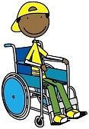

Equipment You May See at Camp

Campers may come with a variety of physical needs & equipment listed below is some of the most common equipment items seen at camp.

**WALKERS**

General Information

* Used when a child needs maximum support to balance in walking.
* Should never be more than one foot length in front of the individual
* Individual should not take a step unless all 4 points of the walker are on the floor.
* When going over a door jamb or onto carpet, individuals should lift up the front end of the walker to prevent falling.

Types of Walkers

* Regular adjustable walkers
  + The four legs can be adjustable for height
  + Often the sides can fold in
* Regular walkers with wheels
  + Either 2 front wheels or 4 wheels
  + Used by those who don’t have enough balance to pick up the walker to move it forward

**CANES**

General Information

* Used by individuals who can walk but need a little support
* Should have solid rubber tips on ends to prevent sliding
* Individuals should have elbows bent 35 degrees for proper fit

Types of Canes

* Single tip – wooden or metal
* Quad – used for wider base (4-tips)

**BRACES**

General Information

* Mechanical devices made of metal or plastic that also use leather or Velcro straps
* They are made to prevent deformities, to correct a position of a body part, to prevent further injury, or to provide support & limit motion at weak joints
* To fit correctly, the joint where the brace bends at the hip, knee & ankle should be at the same level as where the hip, knee and ankle bend
* The cuffs & straps should not be so tight or loose as to cause rubbing or pinching. ALWAYS check for reddened areas on skin

Types

* Long leg braces – come over the knee. May or may not include the hip
* Short leg braces – below the knee. The most common is the DAFO (Dynamic ankle foot orthoses) which is to be worn with a shoe.

**WHEELCHAIRS**

General Information

* Seat belts should be worn at all times
* Lock chair when person is getting in or out of it
* Lock the chair at all times if stopped or unattended
* ALWAYS push the chair at walking speed to prevent loss of control
* ALWAYS seek help if you are not sure you can safely handle it alone
* Remove or move footrests out of the way when transferring the individual

Types of chairs

* Manual
* Power
* Stroller

Wheelchair Safety

**Basic Parts of a Standard Wheelchair**

**ARM RESTS** – Arm rests are usually removable. Many a novice has attempted to lift or fold a wheelchair by grabbing the arms and pulling upward, only to find the chair still stationary, and the two arm rests in his hands in mid-air. The surprise is often amusing, and the disabled person may not have the muscle control & balance to prevent a bad fall. They may also be startled to have their source of support on both sides suddenly removed. So, never lift a wheelchair by the arm rest.

**FOOT RESTS** – Some foot rests are removable. They are attached to each side of the chair, & usually swing outward and fold upward on hinges. When pushing a wheelchair, the foot rest are out of the pusher’s vision, so take care to keep an ample distance between the wheelchair and any pedestrians in front of it. Being bumped by the foot rests can be both annoying and painful to an innocent pedestrian.

Some people don’t have or don’t use foot rests. If this is so, always allow enough foot room for the person in the chair while pushing it, lest they end up with a sore toe from being banged into an immovable object, or a hurt foot which has gotten entangled in the front wheels.

**BRAKES** – There are different types of brakes depending on the chair. Most chairs have a separate brake for each wheel of the chair. Be sure to find out how the brakes are used. Some lock when pushed back & in toward the chair, & others when pushed forward. Some chairs have a foot brake on the back of the chair. Always be sure to put the brakes on when stopping the chair, even for a brief pause, or when the person is being moved in or out of the chair. The brakes must, of course, be locked into place when a person remains seated in the wheelchair while being transported in a vehicle.

**WHEELS** – Take care that nothing gets caught in the spokes of the wheels. Dangling ends of clothing worn by the person in the chair & objects hung onto the back or sides of the chair should all be kept away from the moving wheels.

**SEATBELTS** – It is a safeguard for everyone in a wheelchair to use a seatbelt. Most chairs have a seatbelt and chest harness. Campers who need help controlling their feet and legs may also have straps over their feet. If the wheelchair has any type of seatbelts or straps, they need to be used!

**TILTING RODS** – Modern wheelchairs have two rods close to the ground in the rear. These rods serve as foot pedals for the pusher & it is extremely important to know how to use them.

After getting a good grasp on the handle, the pusher puts one foot on one of the tilt rods, applies a downward pressure which raises the front wheels of the chair from the ground; the chair is then tilted back slightly, and can be maneuvered safely over bumps and holes in the street, door sills, and over any other graduation in levels, such as from the street to a curb. Using the tilting rods may require more caution, but no energy, on the part of the pusher.

**MAJOR RULES** – First, consult with the person you are to push, as to the “dos & don’ts” that pertain to that particular person and chair.

Ask the person you are to push or their parents exactly how his wheelchair works, as each wheelchair is different as the person who uses it. The user knows best, since his wheelchair is his “better half” & is as important to him as a seeing-eye dog is to his master. This applies to children as well as adults.

Ask how the person wishes to be pushed, not only on level ground, but up & down curbs, stairs & so forth. Do not impose unfamiliar ways of doing things.

The person has developed routines which are safe and efficient and in which they have the greatest confidence. This applies not only to pushing the chair, but also to moving an arm or a leg to a more comfortable position, or getting a person into & out of clothing, automobile, etc.

BASIC SUGGESTIONS:

Curbs: When getting a wheelchair from the curb to the street, turn yourself & the chair backwards. After you have stepped onto the street, ease the chair down until the large wheels hit the pavement. To get the chair onto the sidewalk from the street have the chair in front of you, then tilt the chair back far enough so that you may be sure the small wheels are on the sidewalk first. It will then be easy to lift the rest of the chair onto the sidewalk.

Ramps: Descending a long ramp may be more difficult than is suspected. But no matter how short or long a ramp is, always turn yourself and the chair around and go down backwards. The pusher’s body will then keep the chair from picking up momentum. A second person is sometimes needed to grasp the lower part of the chair to help keep the chair under control.

Principles of Positioning

The first five principles address WHY good positioning is so important:

1. COMFORT!!!
2. Prevent or reverse deformities.
3. Provide a variety of positions throughout the day, with the maximum time in any one position no longer than TWO hours.
4. Allow campers to function as independently as possible.
5. Also internal functioning:
   * Respiratory
   * Urological
   * Rheumatism
   * Digestion
   * Circulatory
   * Elimination

The next three principles provide guidelines for HOW to position properly:

1. Align the body for symmetry.
2. Orient the body to MIDLINE.
3. Stabilize the body on a good BASE OF SUPPORT.

Handling Points to Remember

1. Let the camper know exactly what is going on.
2. Encourage campers to assist in any way they can.
3. Use a firm touch, not too hard and not too limp, with good contact.
4. Lift and handle campers at torso and hips rather than lifting arms and legs.
5. Don’t wear jewelry that may scratch or pinch the campers.
6. Use the 10 principles of body mechanics (see page 95)
7. Align the camper’s body from the center out, that is, trunk first, then head, then shoulders, arms, legs and feet.
8. Move smoothly and slowly.

***Wheelchair Preparation***

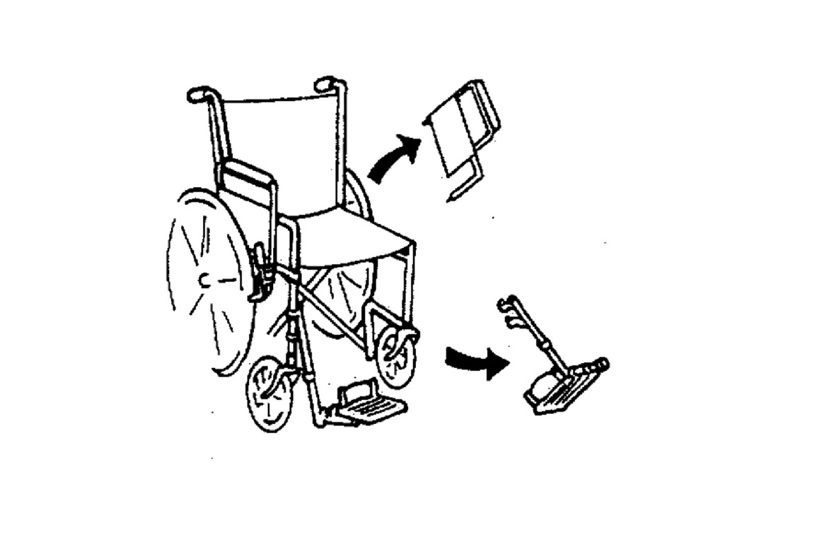

* Position wheelchair at 45-degree angle to transfer surface
* Remove armrest closest to transfer surface, EXCEPT in standing Pivot Transfers
* Remove footrest to transfer surface.

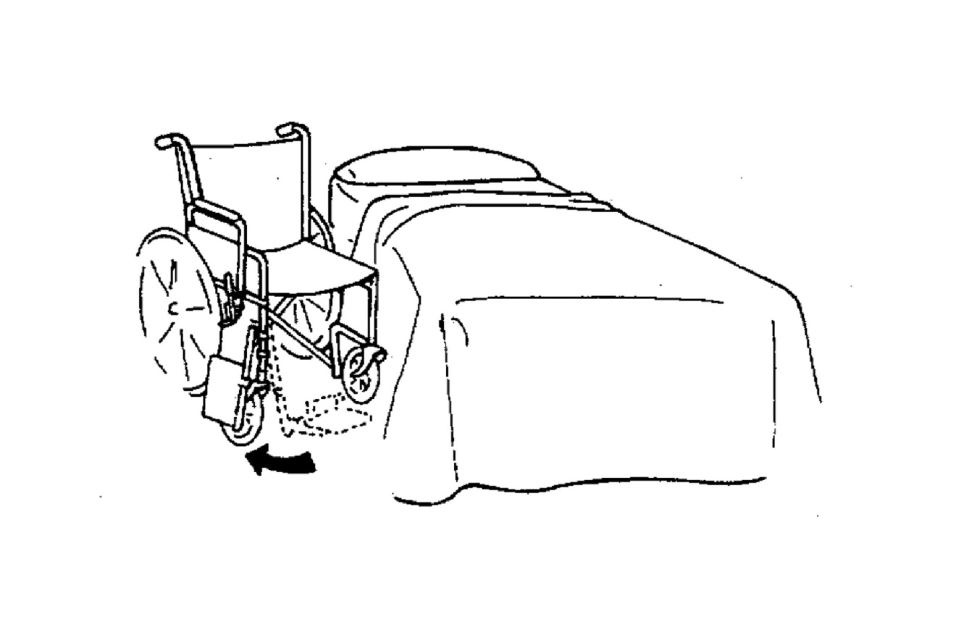

- Swing away other foot rest.

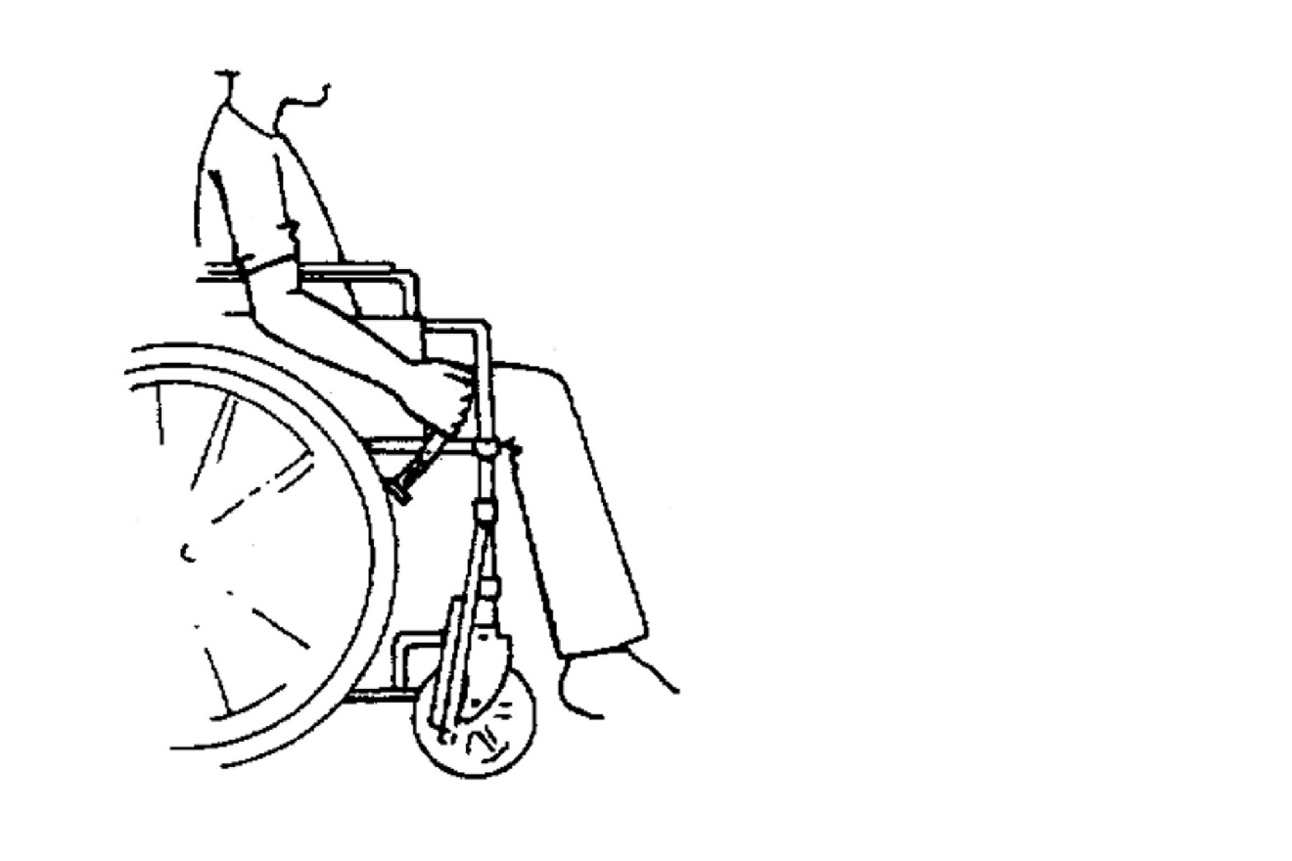

- Lock Brakes.

Transfers

1. Body Mechanics

TEN COMMANDMENTS OF BODY MECHANICS

* 1. Clue the camper in – Be sure camper knows what you’re going to do & how you’re going to do it - & how he or she can help.
  2. Get help – If load (equipment or camper) to be lifted is more than you can handle, regardless of the wait.
  3. Check your footing – Your feet should be apart to give you broad base of support for better balance.
  4. Move Close – Instead of reaching from a distance. Move in and hold object close to your center of gravity (concentrated mass in pelvic area).
  5. Squat – Don’t use “mobility” (back) muscles. Bend hips and knees & keep back straight.
  6. Lift – Use “work” (thigh) muscles by straightening your legs.
  7. Be smooth & synchronized – Avoid strain produced by jerky movement. Get together – it’s a good idea to count 1,2,3 with the person helping you.
  8. Turn – Don’t twist – Shift position of your feet to turn – don’t twist your body.
  9. Don’t lift – when you can push or pull an object. It’s safer & easier.
  10. Teach & Preach – “good words” to others – so all of us will lift well & safely.

1. Types of Transfers
   * Stand – pivot
   * Chair – floor
   * Two Man

Two-Person Transfer

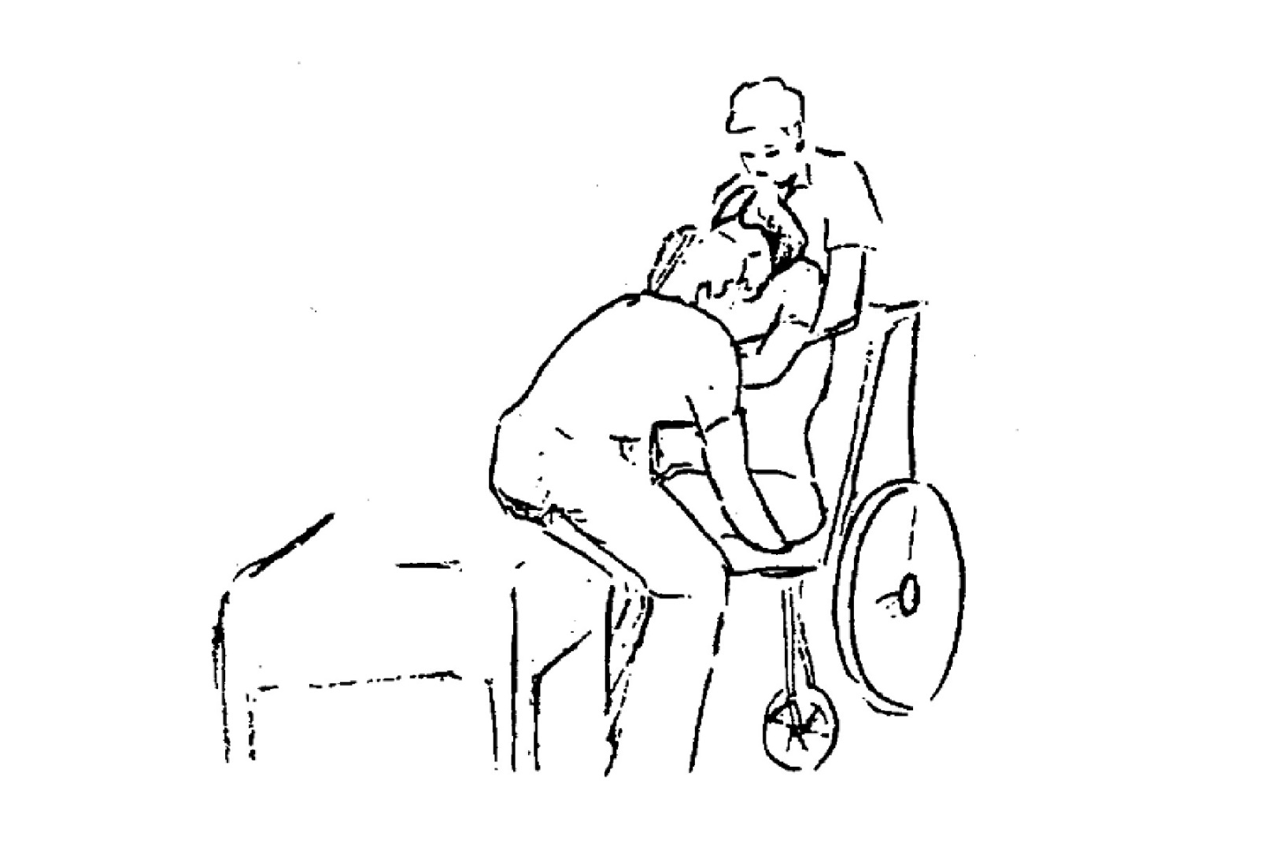

Please note that this describes one method of doing a two person transfer. Modifications may be needed for each client as determined by a physical therapist.

* 1. Prepare the equipment. Arrange the two locations so as to minimize barriers.
  2. Talk to the camper and prepare him or her for the transfer.
  3. One staff member, larger of two, stands behind the camper, the other in front.
  4. The person behind reaches through the camper’s underarms, grasping the forearms.
  5. The person in front grasps under the thighs, locking arms.
  6. If camper is lying, assist him to seating. If seated, scoot to edge of chair or bed.
  7. On a count of three, lift with bent knees and straight back.
  8. Both staff person’s side-step to the target area.
  9. Lower the camper using bent knees and straight back.
  10. Secure camper as needed with seat belt and/or other supports.
  11. Replace any equipment or pieces removed.

***Pivot Transfer:***

For the camper who can bear weight in legs

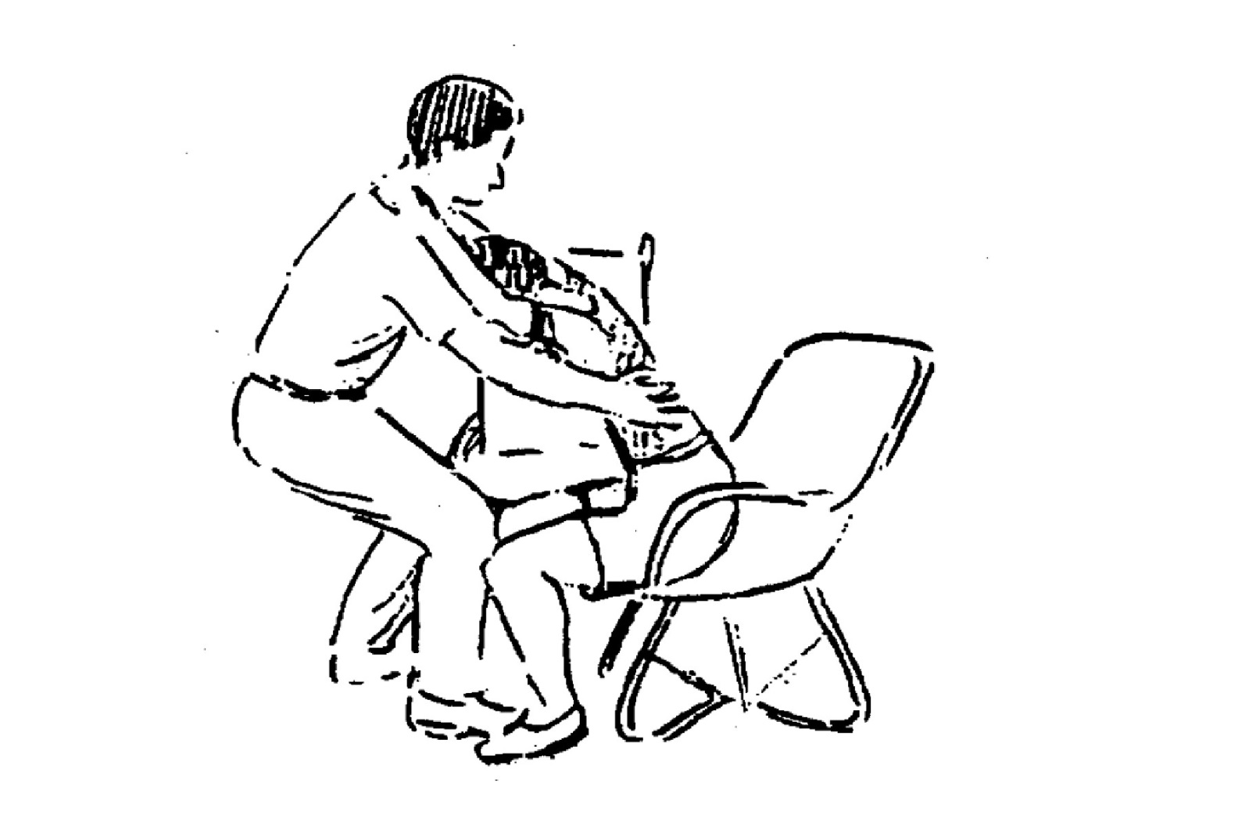

Please note that this describes one method of doing the pivot transfer. Modifications may be needed for each camper as determined by a physical therapist.

1. Place the wheelchair as close to the camper as possible, and remove belts, armrest, footrests, and any other barriers. Lock brakes.
2. Camper scoots out to the edge of the chair with both feet on the floor squarely under body.
3. You place one foot in between the camper’s feet and the other near the chair.
4. Use your knee to stabilize camper’s knee.
5. Hug camper high up under arms.
6. Camper should hold your shoulders and lean forward until she can see her own feet.
7. Rock to get momentum, straighten, pivot with little shuffle steps and lower onto other chair using proper body mechanics (straight back, bent knees).

**WHY SHOULD W-SITTING BE AVOIDED?**

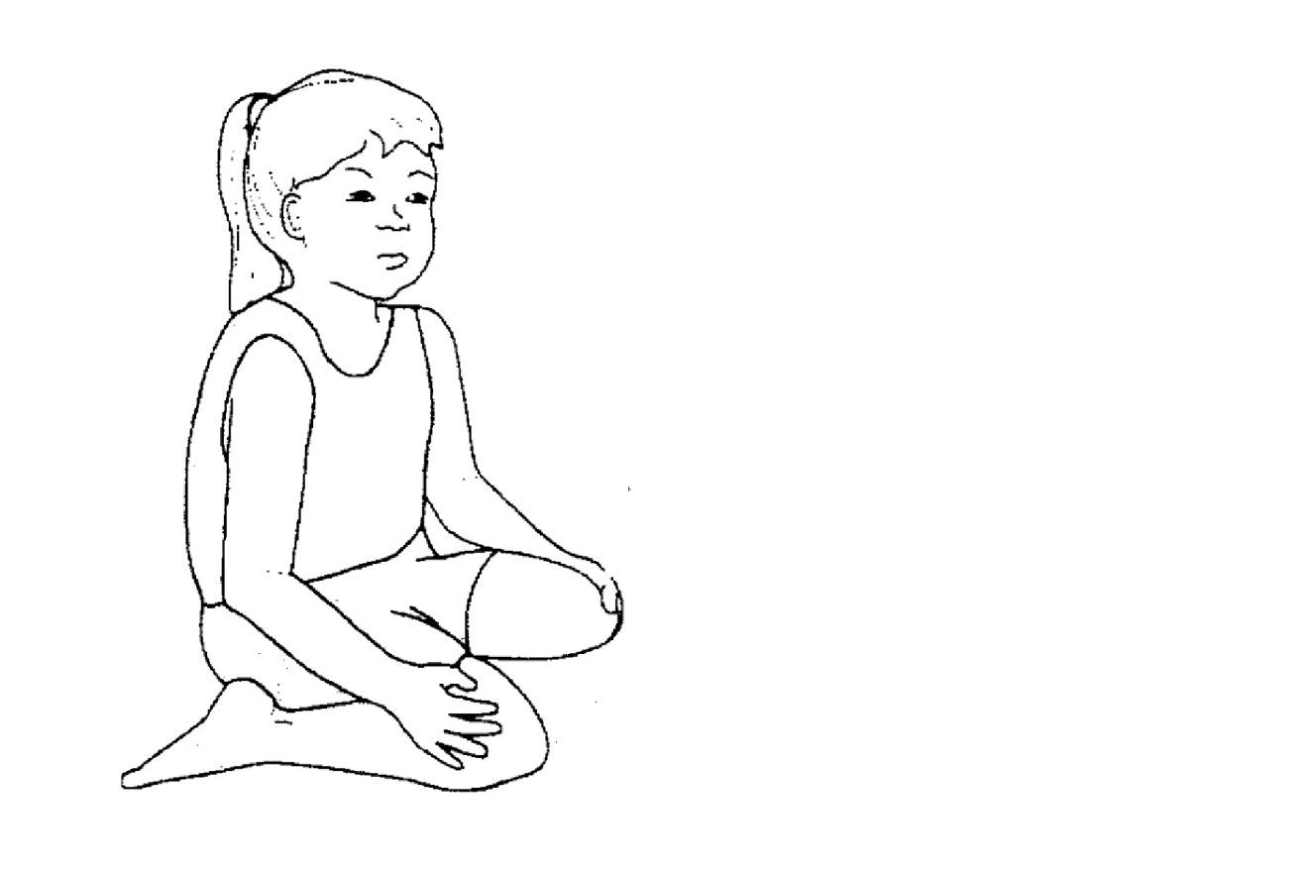

* It can lead to malformations & orthopedic problems in the hips, knees, ankles & feet.
* It can cause contracture deformities that force a child to walk with knees & toes turning in & feet kicking out to the side (knocked-kneed, pigeon-toed).
* It can impair a child’s ability to stand & walk. W-sitting does not require righting reactions for balance or allow the trunk to twist from side to side or shifting weight from side to side. These motions are important in standing and walking.

THE BEST WAY TO PREVENT THE PROBLEMS CAUSED BY W-SITTING IS TO PREVENT IT FROM BECOMING A HABIT IN THE FIRST PLACE.

* Children should be placed in & taught to assume alternate positions.
* If a child assumes w-sitting, help him to move to another position or say “Fix your feet”. It is very important to be as consistent as possible.
* Alternate positions include….
  + Crossed legged or Indian style sitting
  + Ring sitting with the soles of the feet touching
  + Sitting with legs straight out in front which lengthens hamstring muscles
  + Side sitting which encourages rotation of the trunk

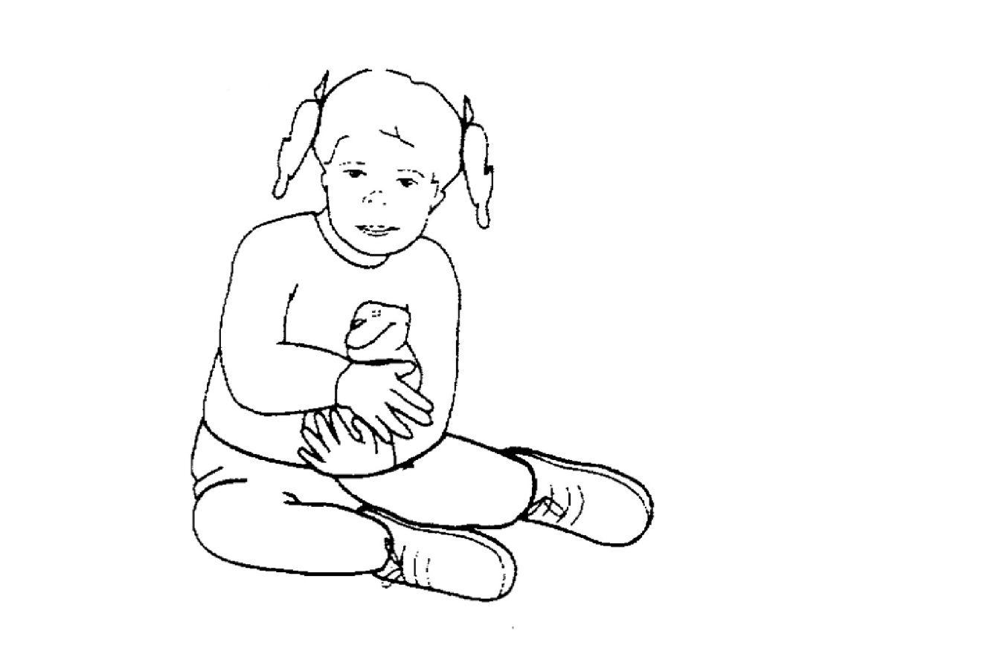

***Games for In-Between Times***

***Games for In-Between Times***

**It is very important to have a variety of games that can be played during transition or down times. Behavior problems occur most when there is not anything for the campers to do. Utilize these games to keep your campers engaged and behaviors limited. Please feel free to add to these games with you own ideas.**

1. **Cloud Watching:** Don’t forget about the simple pleasures that are so often over looked today. This time spent lying in the grass staring up at the sky helps stimulate imagination and brain function and allows for the much needed time to just be. Racing clouds: Each person picks a cloud, and whoever’s reaches a designated landmark in the distance is the winner. Be excited about the race!

2. **Duck Duck Goose**

j0230893

**3. Red Rover**

**4. Simon Says**

**5. I Spy**

**6. Camp Sing a Long**

**7. Red Light, Green Light**

**8**. **Little Sally Walker**: Get everyone in a circle with one person in the middle.   
  
The person in the middle walks around inside the circle while everyone else sings, "Little Sally Walker walking down the street. She didn’t know what to do so she stopped in front of me. (at this point, the one in the middle stands in front of someone and does a dance move)   
  
(Still singing....) Hey girl, do that thing do that thing and switch! (the person that got picked does the dance move) (still singing) Hey girl do that thing do that thing and switch!  
  
The new person now walks on the inside of the circle and continues the game.

**9. How Long is a Minute?** Tell the campers you are going to time a minute on your watch. The camper has to raise their hands once they have counted to a minute in their head. The closest one is the winner. The game can be extended to any amount of time needed.

***Purpose***

***Camp SMILE***



A Letter to You

Dear Friends,

It is our belief that as individuals, we all have been placed on this earth for a specific purpose. That purpose may be to lead our country to a better day as President of the United States. It may be to bring happiness to others by entertaining as an actor or singer does. Or maybe it is to share religious convictions, comfort, & caring as a minister does. It may even simply be to use your knowledge of air conditioning repair or construction work to ultimately bring comfort to others. Whatever we choose to do with our life, be it as a career or on a daily basis, it all has a purpose, the basis of which is GIVING.

But what about us? Is our purpose in this life only to give? We do not believe so. We fully believe that by giving, we receive; therefore, receiving is also a vital part of our purpose in this life. And, in order to discover our purpose, we must discover and acknowledge the many gifts we receive through giving. The entertainer receives applause, acknowledging the fact that he/she succeeded in bringing happiness to others. The repairman may receive a sincere thank you for restoring comfort to someone, thus receiving satisfaction that he has done something good for others. We find it sad to see that many of us never realize the satisfaction of giving, & in return, the joy of receiving.

We are sure you are aware that by choosing to come to camp, you are giving of yourself. The most obvious gift you give is your time. At this point, we are tempted to begin to list the many ways you can give to our campers. But in doing that, we would be interfering in your personal process of discovery. The fact remains, however, that this camp is a camp for people with disabilities & everything that we do is geared toward them. This is the important thing to remember. It is of utmost importance to us & should be equally important to you. We are here to insure that all the campers have a wonderful, happy & successful experience.

But we are also concerned about your experience. You know what you can do for camp, but what can camp do for you? The purpose of Camp SMILE is not only to provide an enriching experience for its campers, bur provide “Special Meaning in Life’s Experience” for you. What can you receive from your experience here? This is for you and only you, to seek & discover. In order to do this, you must be willing to give in every way. But more importantly, you must open your heart and be receptive to the gifts you are about to receive.

Our hope for you is that in the short time you are here, you will learn to close your eyes and see with your heart. Please know that we are here to help you in your process of discovery. We make you one promise: By looking in your heart, you will find LOVE.

With Love, The Leadership Team

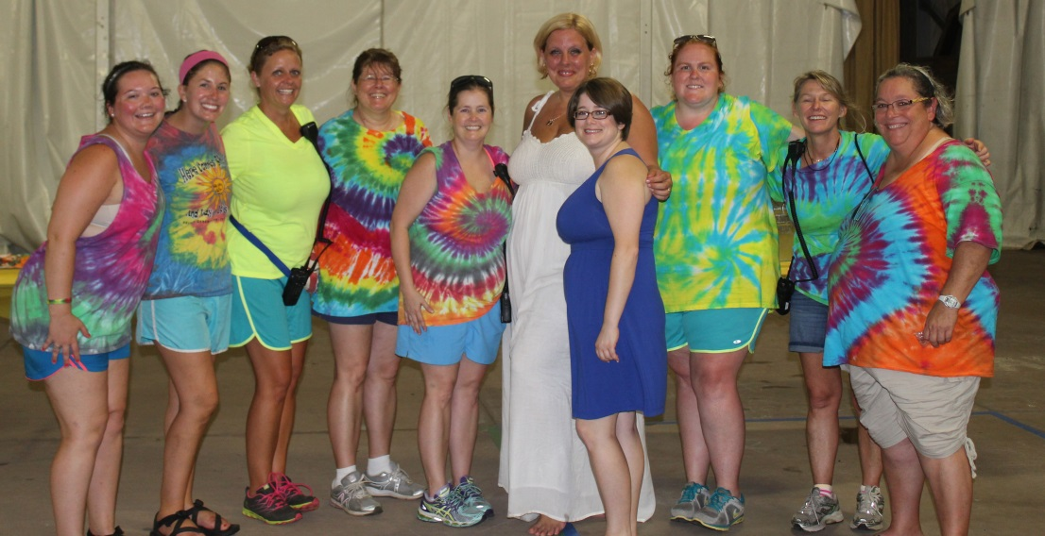

Discovery of Purpose

* Camp is like family, it doesn’t matter how long you are away, you can always pick back up where you left off.

Dannah Lowell Chappell

* + Camp is home. Home is where the heart is. So camp is where the heart is; it’s impossible not to put all of your heart into it: into the campers, into the SMILE

Jordan Lowell

* + Camp means new experiences & great memories.

Katy Givhan Sumrall

* + Camp is a place to find yourself in others.

Virginia Breland

* + Camp is who we are.

Savannah Wallace & Matrisza W. Alvarez

* + There is only one word to completely describe camp: LOVE. It is a love you will never find nor experience anywhere else, that will only leave you craving more. The day camp ends each year is the day that I am wishing I was back again.

Melanie Tew

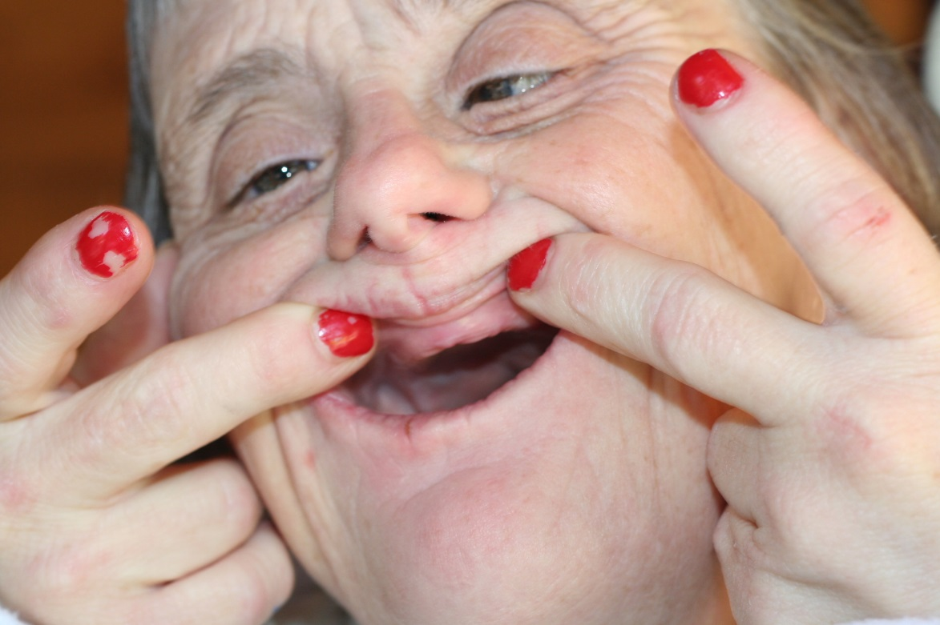

***Special People Smile***

By: Martha White, July 6, 1979

God created special people so that others might see

That they take their lives for granted and how trying life can be.

He had a plan for my life and now I see

That you’re the special people He created for me.

You’ve taught me how to love, to have faith, to say, “I can”,

To trust and have patience, to try and understand;

So when you ask why I’m always smiling, I’ll think of you and sing

This song to let them know what joy to me you bring.

You’ve given me special meaning in life’s experience; that is why I smile.

And because of you I’ll go down each road in life Smiling mile by mile.

So when this song is through I want all of you to truly see

That your existence in my life means God has smiled down on me.

You’re all God’s special ed teachers in many different ways.

Some teach others to walk and eat, how to talk and how to play.

Then there are those who teach us how to laugh and how to cry;

And when we fall, how to get right up and give it another try.

Now I thank God for you – each and every one.

There are very few like you under His great sun.

So always keep on teaching and smile all day through,

And I’ll pray that you’ll be blessed like He has blessed me with you.

You’ve given me special meaning in life’s experience; that is why I smile.

And because of you I’ll go down each road in life smiling mile by mile.

So when this song is through I want all of you to truly see

That your existence in my life means God has smiled down on me.

The words & music to “Special People Smile” were written by Martha White while a

Counselor at Camp SMILE (Special Meaning In Life’s Experiences) at Citronelle, Alabama.

The camp for the mentally & physically disabled children & adults is sponsored by

United Cerebral Palsy of Mobile.